DocuSign PageUp Security Access Form

Effective February 27, 2025, we are now using a new DocuSign form for our PU Security Access Requests. In the short term we will continue to accept our older “PDF” documents, but we encourage everyone to use the new DocuSign form.

At UH, DocuSign is accessible via AccessUH using CougarNet ID (See screenshots and steps below).
- Click DocuSign Icon in Access UH (If the DocuSign Icon is not visible, please email DocuSign@central.uh.edu to request access.)
- Select Start, Use Template
- Click Shared with me and select UHS HRIS PageUp Access Request, and click Add Selected
- Enter all recipients names and email addresses
- Click Send
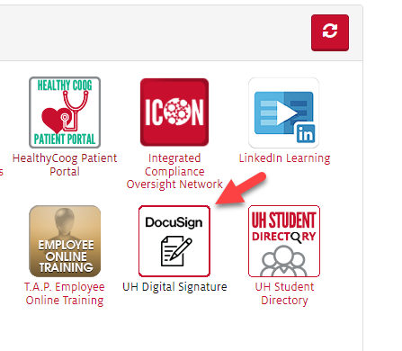
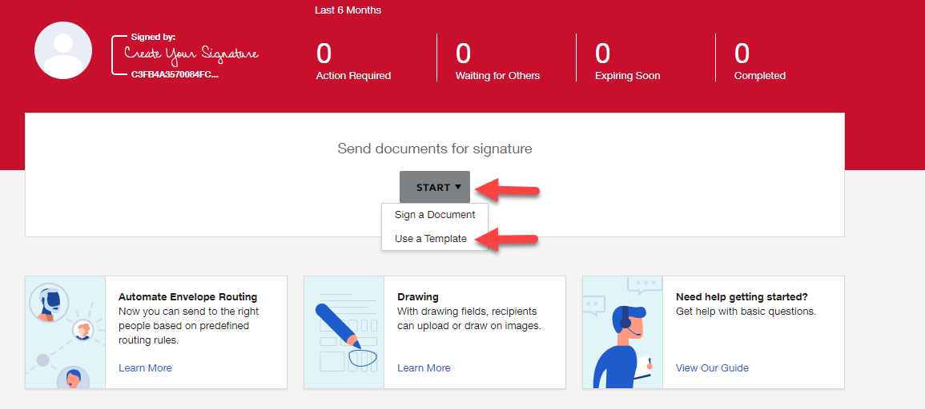

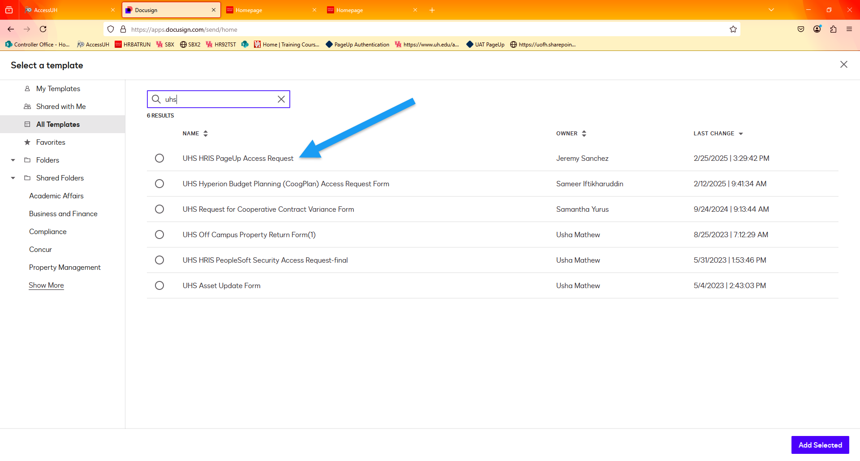

A DocuSign SharePoint site with training materials, video tutorials, FAQs, etc., is available to all UH university employees.

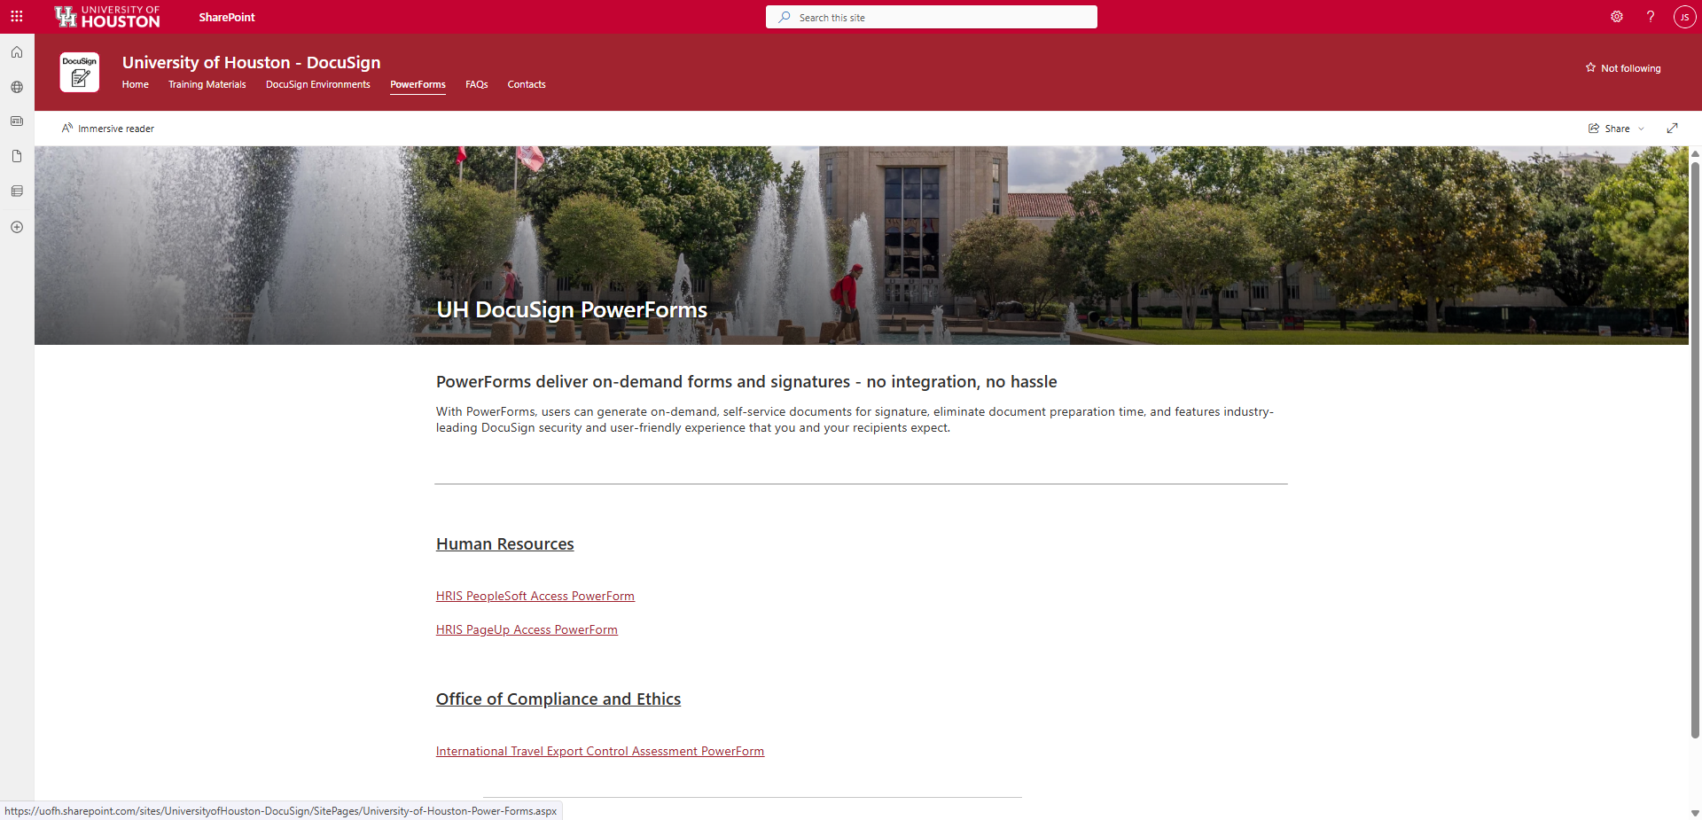

For any additional information related to DocuSign at UH please email DocuSign@central.uh.edu

