Running Daily Funding Telecheck Report:
- Go to website: http://www.firstdata.com/telecheck/index.htm
- Click on TeleCheck eView Login
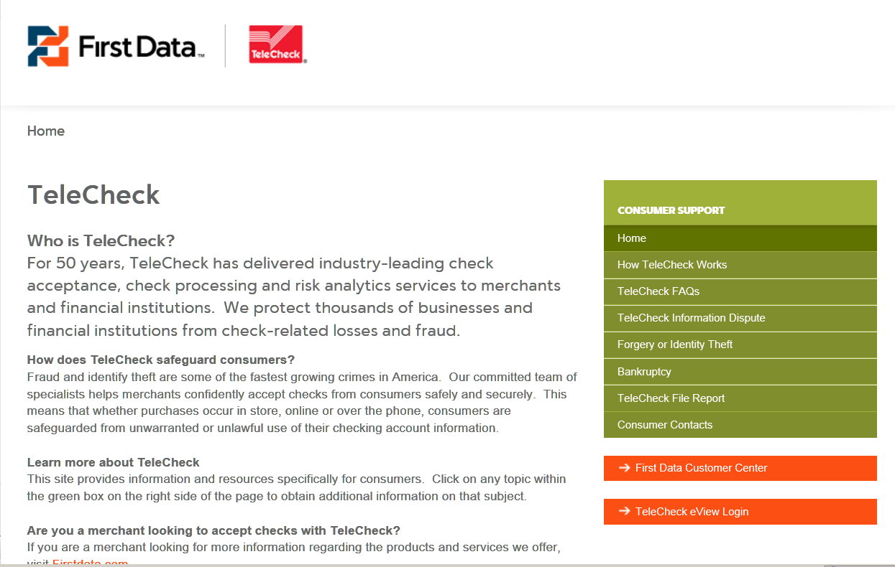

- Enter User Name and Password

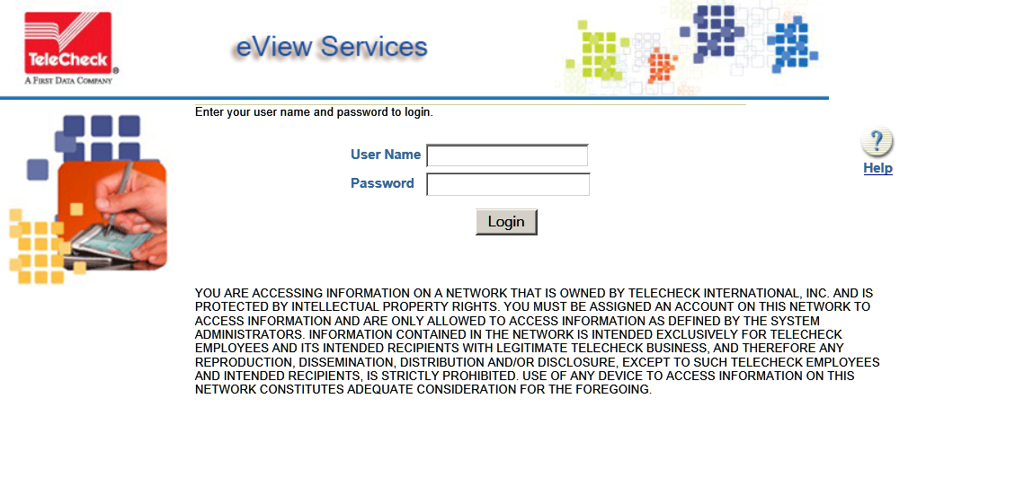
- Click on Funding tab
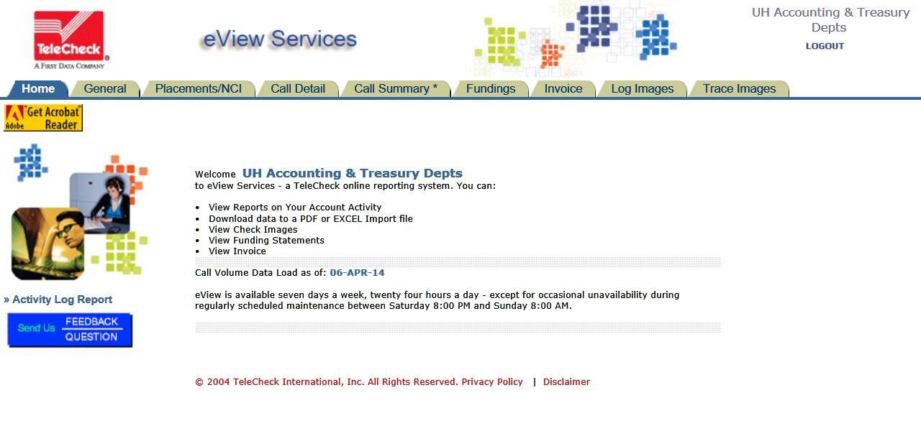
- Choose the MID (for example: 38251848) and Frequency will be daily. Then click on View Report
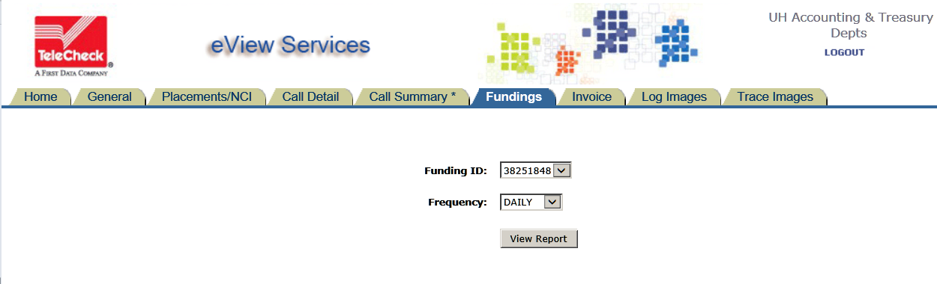

- There will be a list of all available daily funding reports. For example, report 38251848_04042014 will list checks scanned on 04/03/2014 for machine 38251848. Click on any report to open it and then save it for later use.
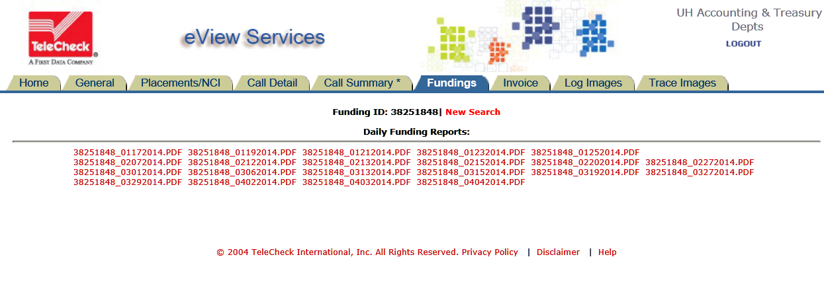
- Below is a sample report for 38251848 scanned date 04/03/2014 which is normally one date before the funding date (04/04/2014).

