IDC Analysis Worksheet Explanation

The two things that this IDC Analysis Worksheet provides are:
1) How much IDC should be charged to your grant to date for the current period you are reconciling?
2) How much IDC should be encumbered to date for the current period you are reconciling?

IDC Analysis Worksheet  Section 1. Calculating IDC Charged | From the PeopleSoft 1074, PTD Rev/Exp Column.
 | 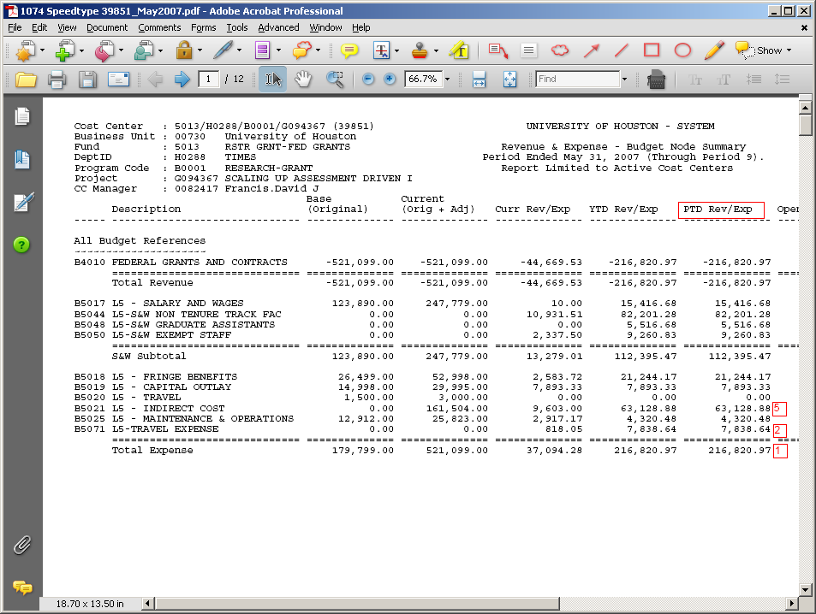
  ONE F&A RATE
  Total Amount: |  | $216,820.97 | 1
  Less Equipment: |  | 7,893.33 | 2
  Less Stipends: |  | 0.00 | 3
  Less Subcontract: |  | 0.00 | 4
  Less F&A: |  | $63,128.88 | 5
  Base Amount: |  | $145,798.76 | 6
  x % Rate: |  | 49.00% | 7
  F&A Earned: |  | $71,441.39 | 8
  F&A Charged: |  | $63,128.88 | 9
  CHARGE IDC |  | $8,312.51 | 10

1 | Total Amount: | Total amount expended for the period. (PTD Rev/Expenses from the 1074).
2 | Less Equipment: | Total equipment expended for the grant period.
3 | Less Stipends: | Total stipends expended for the grant period.
4 | Less Subcontract: | Total subcontracts expended for the grant period.
5 | Less F&A: | Total IDC expended for the grant period.
6 | Base Amount: | this is a calculated field. It is the amount of direct costs expended to date that are subject to IDC. Total amount expended less any expense categories that are not subject to IDC, such as equipment.
7 | x % Rate: | Enter the IDC rate for the grant. You can obtain this from your Notice of Award or RD2K.
8 | F&A Earned: | Amount of IDC that should be charged based on the expenses for the period.
9 | F&A Charged: | Amount of IDC that was actually charged.
10 | CHARGE IDC | This is the amount of IDC that must be adjusted.

IDC Analysis Worksheet  Section 2. Calculating IDC Encumbered | From the PeopleSoft 1074, PTD Rev/Exp Column.
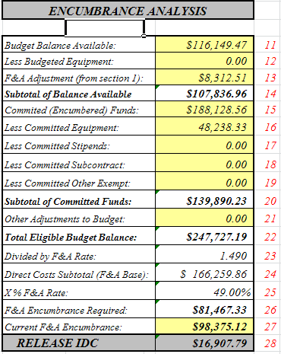 | 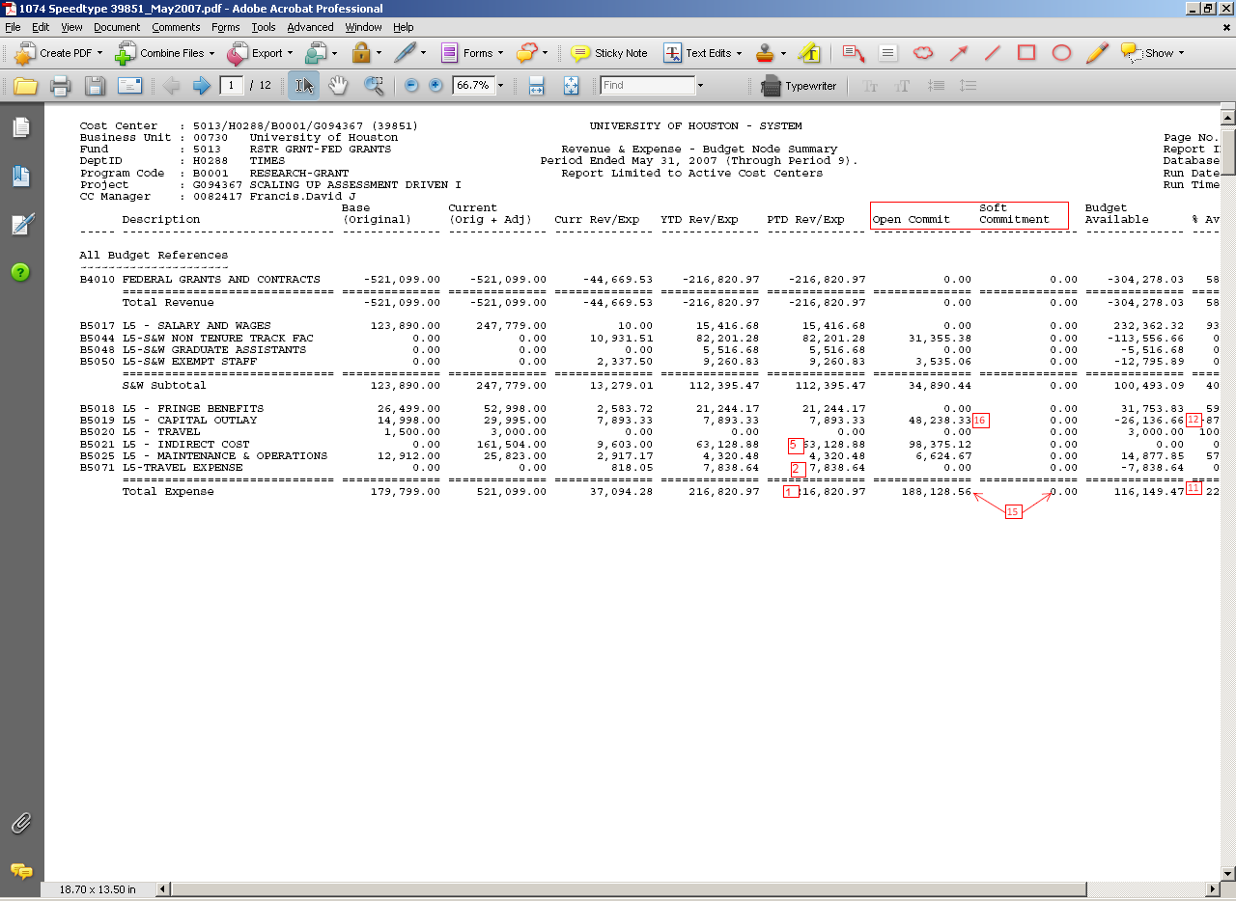

11 | Budget Balance Available: | The overall budget balance of the cost center. (1074 Budget Available).
12 | Less Budgeted Equipment: | The available budget balance for “Equipment.” If it is negative, enter 0.
13 | F&A Adjustment (from section 1): | enter the amount from Section 1 “Charge IDC”. This is the IDC adjustment necessary for actual IDC charged.
14 | Subtotal of Balance Available | calculated field. It is the Budget Balance Available less the budgeted equipment and F&A adjustment.
15 | Committed (Encumbered) Funds: | Total Open Commitment + Total Soft Commitment
16 | Less Committed Equipment: | Any equipment in the Open or Soft Commitment column.
17 | Less Committed Stipends: | any stipends in the Open or Soft Commitment column.
18 | Less Committed Subcontract: | any subcontracts in the Open or Soft Commitment column.
19 | Less Committed Other Exempt: | any other committed expenses that are not subject to IDC.
20 | Subtotal of Committed Funds: | calculated field. Subtotal of all the committed funds.
21 | Other Adjustments to Budget: | Any other necessary adjustments needed.
22 | Total Eligible Budget Balance: | Calculated field. Subtotal Balance available = subtotal committed funds + Other Adjustments to Budget.
23 | Divided by F&A Rate: | Calculated field. (IDC rate entered from Section 1).
24 | Direct Costs Subtotal (F&A Base): | Calculated field
25 | X % F&A Rate: | Calculated field. (IDC rate entered from Section 1).
26 | F&A Encumbrance Required: | Calculated field. This is the amount of IDC that should be encumbered.
27 | Current F&A Encumbrance: | Enter the amount that is actually encumbered from the IDC line of 1074 Open Commitment column.
28 | RELEASE IDC | Calculated field. This is the amount of IDC that should be released, or encumbered.

