Instructions for Sharing a Private Query

By definition, a public query is one that can be used by all PeopleSoft users that have access to the query tool. In contrast, private queries are limited to an individual user. However if you have the ability to create your own queries (Query Manager), it is possible to share a private query with another user by issuing a copy of it to them.

The following steps will guide you through the process of providing a copy of a private query to another user:

Step 1

Navigate to Query Manager and enter search criteria to retrieve the desired query. Click Search.

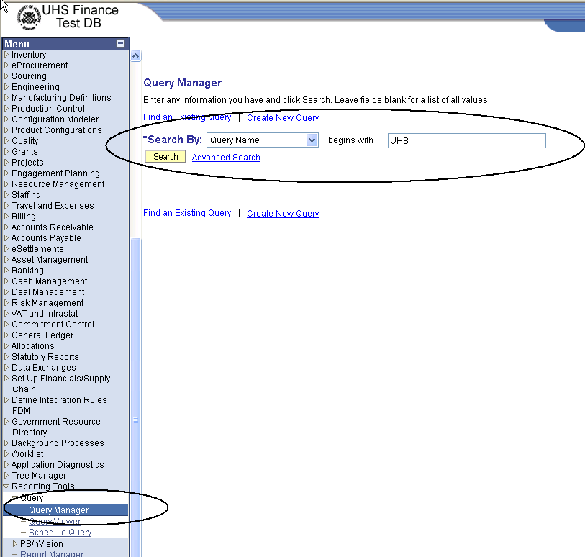

Step 2

Select the query that you wish to copy. Use the drop-down Action window to select the Copy to User action. Click Go.

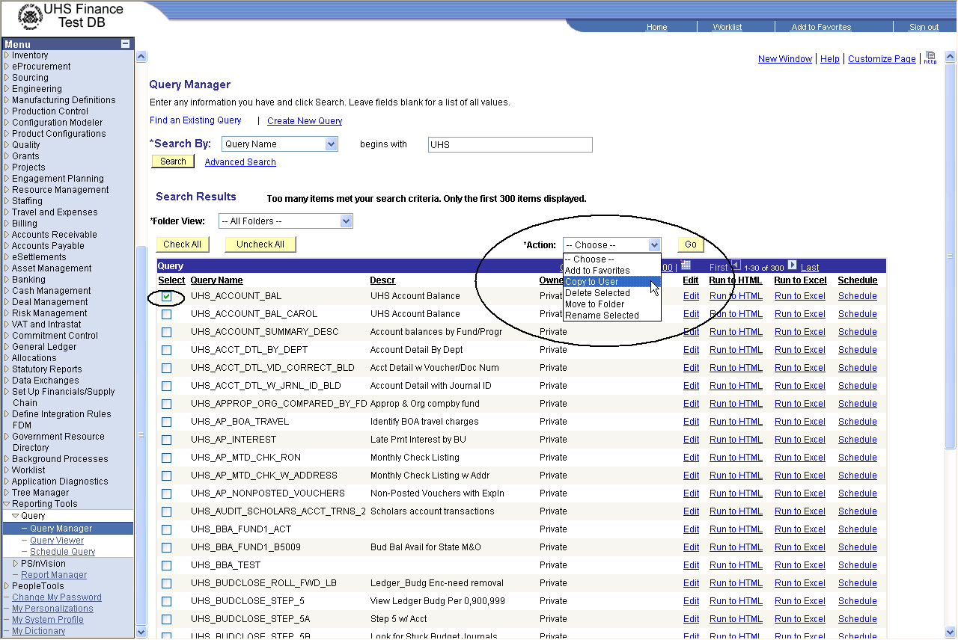

Step 3

Enter the UserID of the user to which you want to send a copy. Click OK.

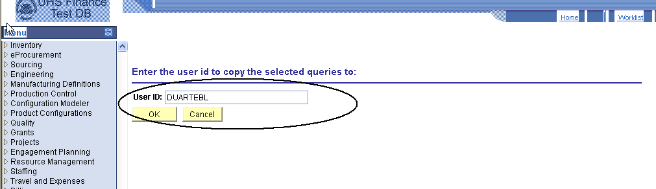

Step 4

A confirmation message will appear indicating that the copy was made. Click OK.

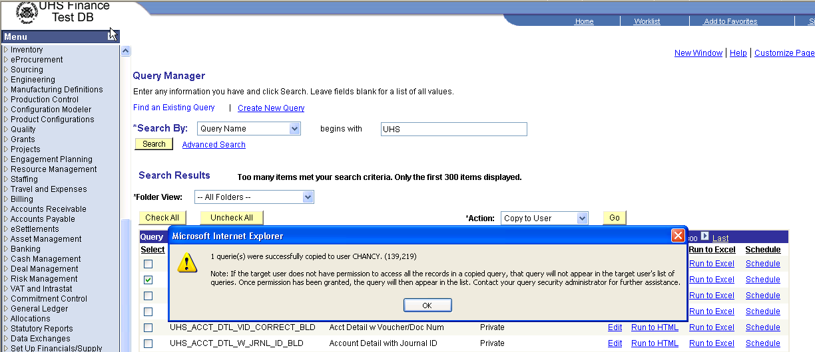

The copy of the query will appear in the private query list of the recipient user.

