Reports that Use the DEPTID_ROLLUP Tree

- 1060 Reports – Always uses tree. Must run at level 3 or above.
- 1070 Reports – Always uses tree. Must run at level 4 or above.
- 1074 Report – Use of tree is optional. May run at any level.
- 1063 Report - Use of tree is optional. May run at any level.
- 1033 Report - Use of tree is optional. May run at any level.
- 1016A-D Reports – Always uses tree. May run at any level.

Reports that Do Not Use the DEPTID_ROLLUP Tree

- 1016 Report – Does not use tree. Runs on a department range.
- 1016E Report – Does not use tree. Runs on all departments.

Instructions for Viewing Levels on the DEPTID_ROLLUP Tree

1. Navigate as indicated below and select the DEPTID_ROLLUP tree for 8/31/12.

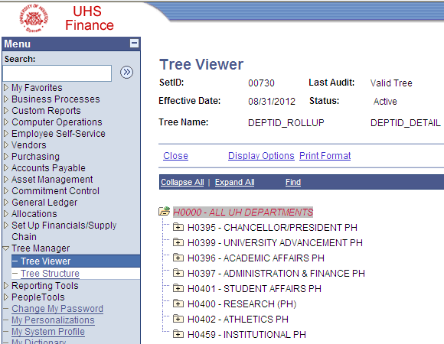

- Select Display Options.

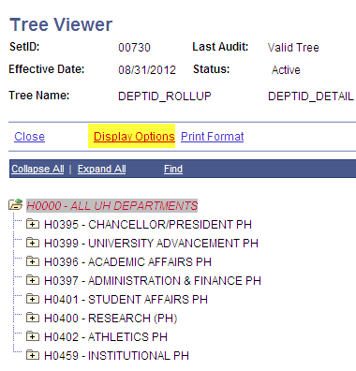

- Check the Display Levels box and select the Update button.

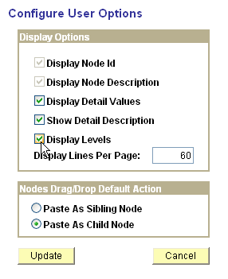
- Select Print Format if you want to print the tree. Otherwise, you can view the entire tree by selecting Expand All or view a single division by selecting the plus sign next to the DeptID for that division.

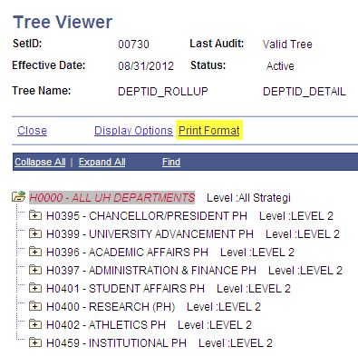

Purpose of Placeholder Departments

Placeholder DeptID’s are only used for running reports. They should NEVER be used as part of a cost center.

You can recognize placeholders DeptID’s because they have a “PH” after the department name in DEPTID_ROLLUP tree.

Running 1060 Series of Reports

1060 Reports – Subtotals at Level 3 on the DEPTID_ROLLUP Tree. Run at Level 3 or above.

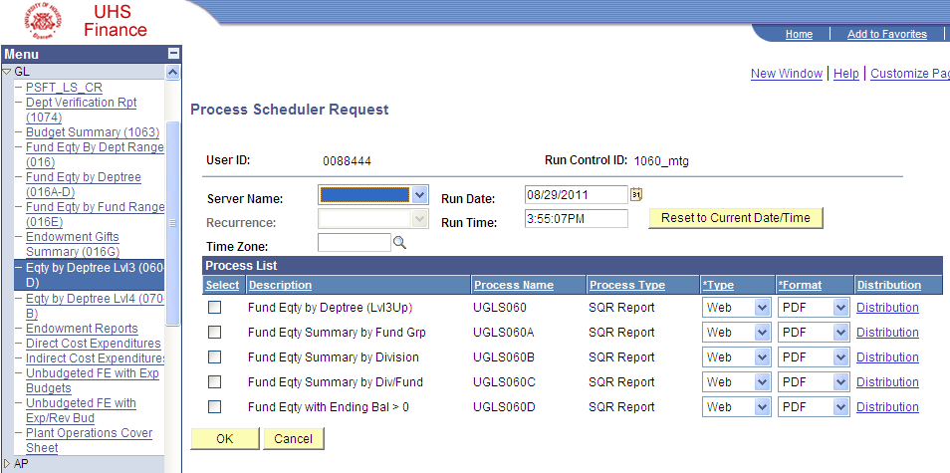

Note: The 1060 reports will automatically create a CSV file to go with the PDF.

Running 1070 Series of Reports

1070 Reports – Subtotals at Level 4 on the DEPTID_ROLLUP Tree. Run at Level 4 or above.

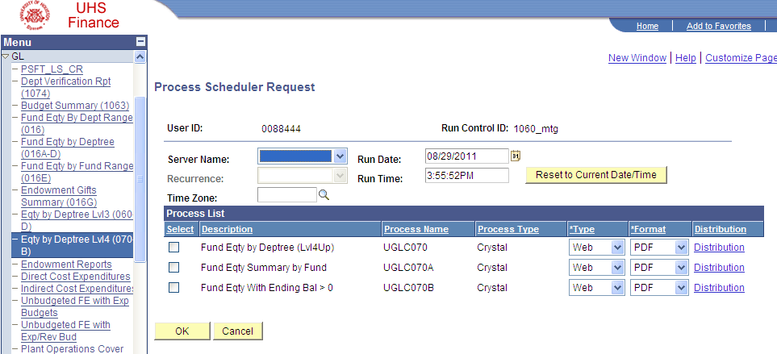

Note: Format of 1070 report can be XLS (for Excel spreadsheet) or PDF (for PDF file).
Example of Levels on the DEPTID_ROLLUP Tree
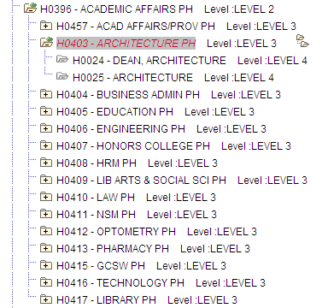

Examples of Running the 1060 and 1070 Reports

Example 1: Run a report that gives one subtotal for the entire College of Architecture.

Solution: Run the 1060 report for H0403. The 1060 report subtotals at level 3.

Example 2: Run a report that gives a subtotal for each department within Architecture.

Solution: Run the 1070 report for H0403. By running the 1070 report on a level 3 department (H0403), you get a subtotal for each level 4 department beneath it.

Example 3: Run a report that only gives a subtotal for the Architecture Dean’s Office.

Solution: Run the 1070 report for H0024. When you run the 1070 report on a level 4 department (like H0024) you get that specific department.

