How to Make Changes to an Existing Query
Change the Output
Add/Remove a Field - On the Query tab, simply check the box next to the fields that you want to display in the query output. Uncheck the box to remove them. Note: You do not have to display a field in the output to use it as criteria.
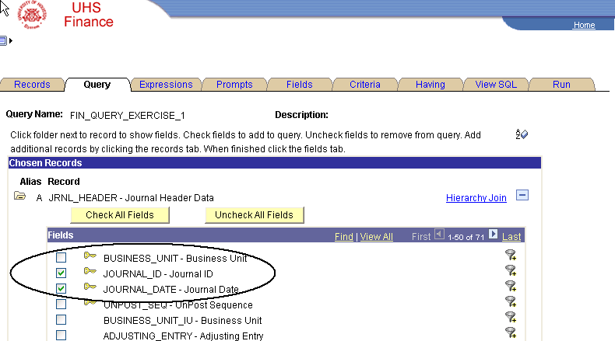

Re-order and Sort the Fields – On the Fields tab, use the Column Order and Sort Order buttons in the upper right hand corner of the page to designate the order in which the data fields should appear and how the values should be sorted in the query output.
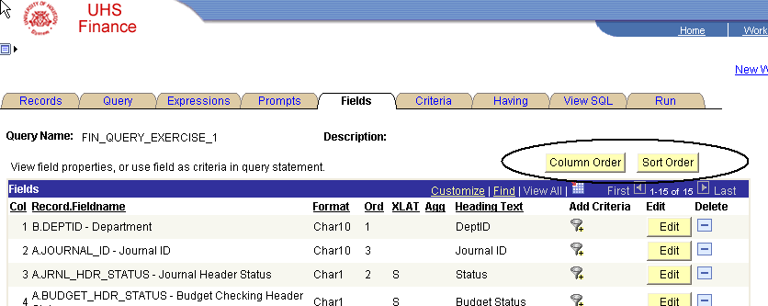

Once on the Column Order page, simply type the desired order number in the boxes to the right of the fields. Click OK.
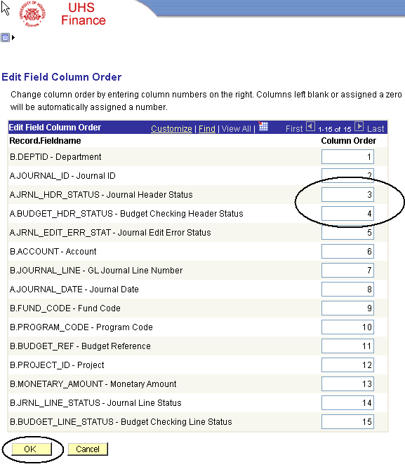
Once on the Sort Order page, simply type the desired order number in the boxes to the right of the fields and select the direction, ascending or descending, using the drop-down boxes. Click OK.
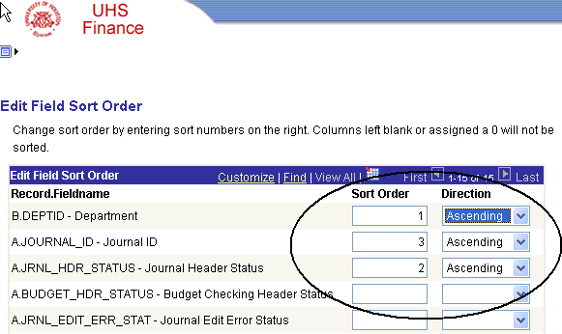

Change the Descriptions – If a field chosen for the query output has a value of N in the XLAT column on the Fields tab, you have the option of displaying a short or long description in place of a code. (i.e. E is displayed as Errors)
Click on the Edit button for the field you want to modify.
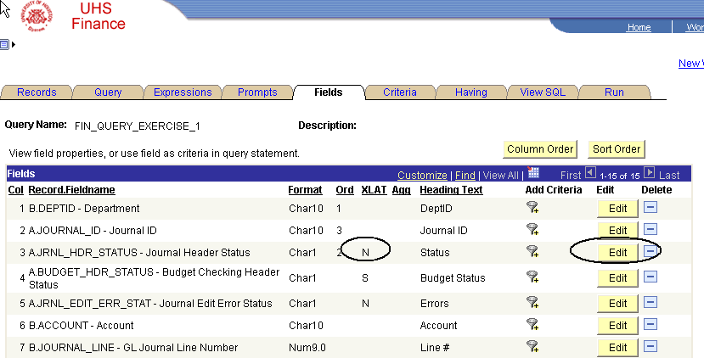
In the Translate Value box, select either the Short or Long radio button. Click OK.

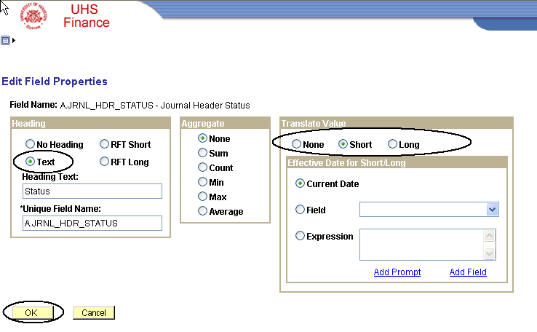
Change the Criteria and Add Prompts
In order to change the Condition Type or the Expression 2, click on the Edit button to the right of the row you wish to change. Condition Type equal to is the default and limits the criteria to a single value.
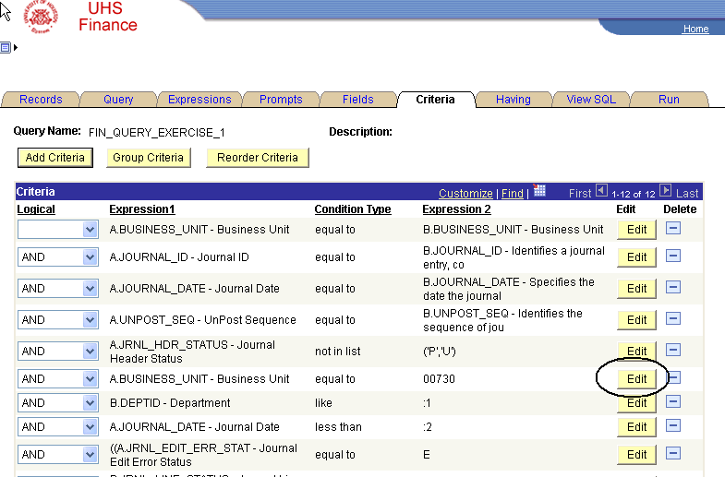
Use the Condition Type drop-down box in the center of the page to select the desired condition.
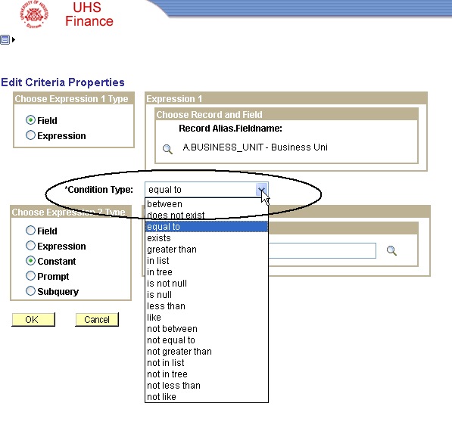
Like – The criteria condition Like enables the query runner to use wildcards (%s) when running the query. Using the Like criteria makes the query more flexible. For example, if the desired result is all account values that start with 5, the user would enter 5%.

In List – The In List criteria condition allows the query runner to designate a fixed number of values that the query should search for when retrieving the data. Select the In List condition type and the List Members box appears. Click on the magnifying glass in the List Members box.

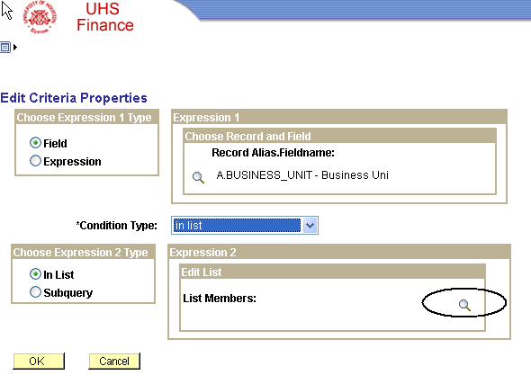

Type the values in the Value box and click the Add Value button to add them to the List Members. Click OK.

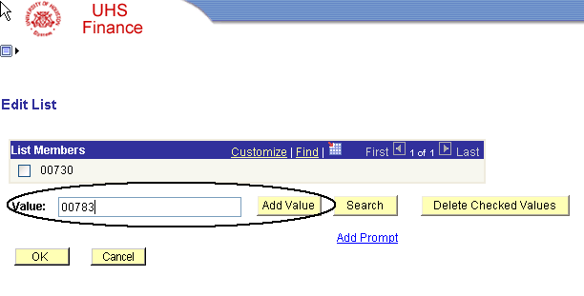

The List Members are defined as criteria.
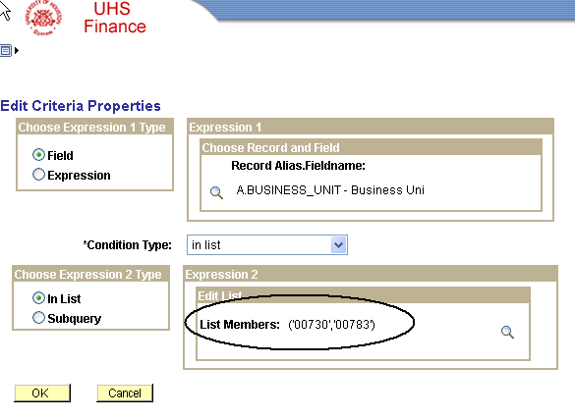

Between – The Between criteria condition allows the query runner to designate a range of values that the query should search for when retrieving the data. When the Between Condition Type is selected, two boxes appear for designating the range.
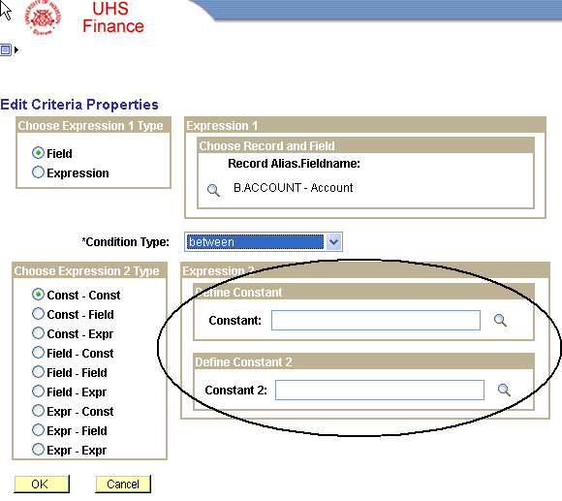
Enter two values that represent the desired range. Click OK. The criteria will display on the Criteria tab as follows:

Add a Prompt – The criteria expression Add a Prompt directs the query to prompt the query runner to supply a value at the time the query is run. Click the Edit button for the data field for which you want a prompt. Select the Prompt radio button and the Prompt box appears to the right. Select New Prompt.
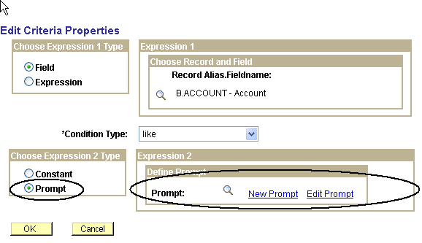
Use the Edit Type drop-down box to select No Table Edit. Click OK.
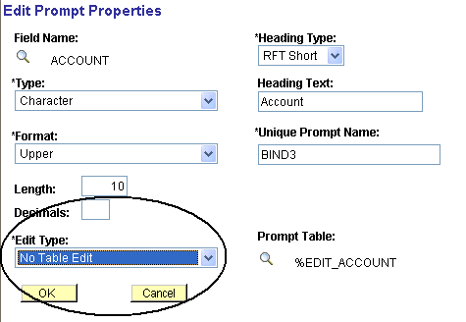
The new prompt will be given the next available number.
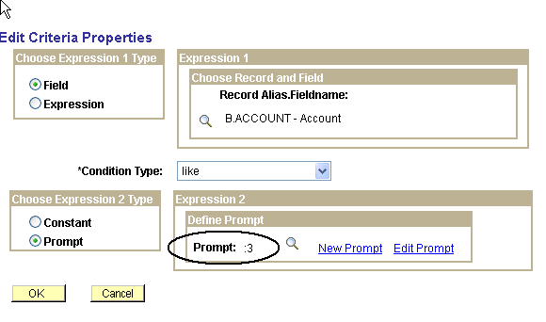
And will appear on the Criteria tab as follows:

