## Self-Powered Distributed Sensors/Reporters for Integrated Offshore Asset and Local Environment Monitoring

**PI: Jiming Bao**

**1. Introduction**

**1.1 Project Background**

Monitoring floating and subsea offshore assets and their surrounding environments is essential to safe and environmentally responsible oil exploration and production in the Gulf of Mexico. An ideal solution is to deploy distributed sensors/reporters that can sense local conditions and then report to the control center. A major challenge to this approach is the electrical power supply in the remote deep sea, especially the distributed power to individual sensors. This issue becomes more severe when there is a power outage due to anthropogenic or natural causes or disasters. This project will address self-powered distributed sensors/reporters for integrated offshore asset and local environment monitoring and practical implementation of organic electrochemical transistors for subsea detection. The Subsea Systems Institute (SSI) demonstrated that organic electrochemical transistors (OECTs) could be used as sensors for detecting trace organic molecules in seawater, potentially enabling rapid and early detection of pipeline leaks. The approach involved the combination of OECTs with a molecularly imprinted polymer (MIP) layer designed to respond to a specific contaminant. However, there needs to be more understanding of how these sensors will respond in realistic seawater conditions, which includes variations in temperature and deep ocean currents driven by density and temperature gradients. In this project, SSI, looks to develop self-powered distributed sensors/reporters for integrated offshore assets and local environmental monitoring.

* 1. **Purpose of the Research**

• Developing self-powered sustainable reporters/sensors that can be attached and deployed to assets of an offshore platform for integrated asset monitoring and management;

• Designing self-powered blinkers that can emit flashing lights as a reporter. Using the triboelectric effect, these sensors, reporters will harvest energy from ocean waves or marine currents.

**2. Project Overview**

**2.1 Project Summary**

**• Briefly describe the project content.**

The primary task of the project is to design and manufacture one or two types of triboelectric nanogenerators. After extensive and thorough research, the task has been focused on two types: contact-mode triboelectric nanogenerators and non-contact externally excited induction generators.

**• Outline the basic methods and main approaches used in the research.**

In the experiment, we tested over twenty types of plastic and other materials as dielectric materials, setting up more than fifty pairs of material combinations to evaluate their triboelectric properties. This was done because different materials have varying tendencies to gain or lose electrons; some are more likely to gain electrons while others tend to lose them. We measured their current and voltage using a precision electrometer. Subsequently, we designed and fabricated various types of triboelectric devices, characterizing them by the number of lights they could illuminate.

* 1. **Major Milestones**

**• List key events and milestones in the project timeline.**

1. We selected the materials with the highest tendency to gain or lose electrons from these **20** types of materials: polyethylene (PE), polypropylene (PP), polyvinyl chloride (PVC), polystyrene (PS), polyethylene terephthalate (PET), acrylonitrile butadiene styrene (ABS), polycarbonate (PC), polymethyl methacrylate (PMMA), polyamide (Nylon), polyoxymethylene (POM), polytetrafluoroethylene (PTFE), polyurethane (PU), polybutylene terephthalate (PBT), polyphenylene oxide (PPO), polylactic acid (PLA), polyether ether ketone (PEEK), polyimide (PI), polyvinyl alcohol (PVA), ethylene vinyl acetate (EVA) and paper. Ultimately, we selected the combination of PTFE and PU (**Figure 1**). Among them, PTFE has the highest tendency to gain electrons, while PU tends to lose electrons more readily. Additionally, PU has a certain thickness and is relatively soft, which can effectively reduce damage caused by hard friction, thereby extending the lifespan of the device.

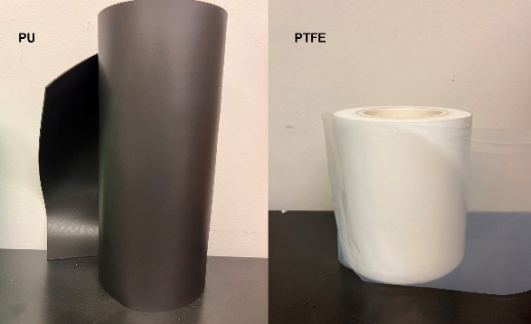

**Figure 1.** PU and PTFE

1. During the device model selection stage, we focused on sliding and contact-separation models. Both exhibit similar levels of electricity generation performance, but the contact-separation model is significantly constrained spatially and cannot leverage its unique advantages within multilayered limited space. In contrast, the sliding model allows for arbitrary stacking within a given space, with its output power increasing exponentially. This aligns closely with our expectations, leading us to prefer developing the sliding model. Schematic of sliding mode and its performance is shown below:

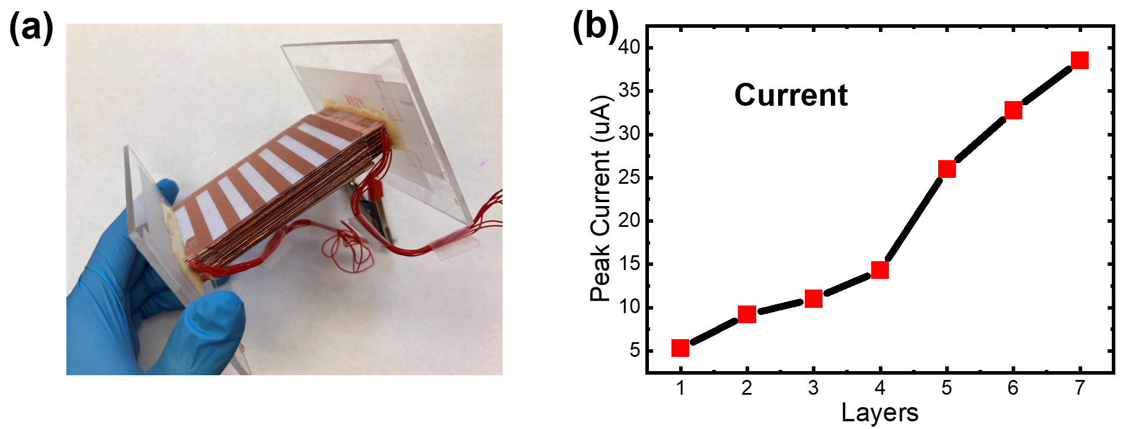

**Figure 2.** **(a)** Schematic of multilayers sliding triboelectric generator. **(b)** Peak current with number of triboelectric layers.

1. In the model improvement stage, we optimized and upgraded the sliding friction generator from its original plug-in model to a multi-layer rotating model. This model's advantage lies in its ability to generate electricity synchronously, thereby minimizing energy collection losses due to asynchronous friction. **Figure 3(a)** depicts the rotor and stator, with the rotor covered in copper and PTFE, and the stator covered in copper and PU film. **Figure 3(b)** is a schematic diagram, both requiring support from acrylic plates, as shown in **Figure 3(c)**, an experimental snapshot.

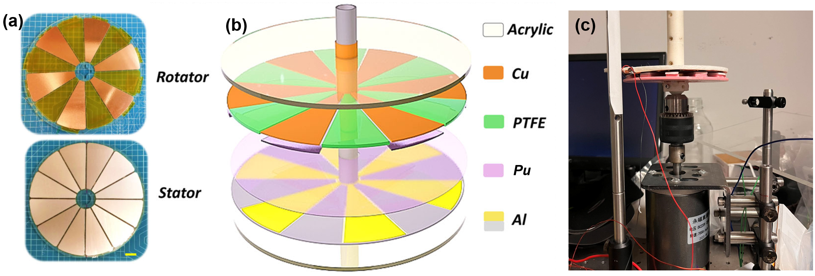

**Figure 3.** Rotating mode triboelectric generator. **(a)** Rotator and stator. **(b)** Schematic of rotating mode. **(c)** Experiment snapshot.

1. We designed a non-contact rotating model where the principle involves inducing and inducing charge distribution on the PU film on the stator using a charged rotor. The advantage of this model is the complete elimination of losses caused by friction between PTFE and PU, further extending the device's lifespan. **Figure 4** shows “TENG” LEDs lighted up by non-contact generator. However, this device requires a self-excitation system, which is still under refinement.



**Figure 4.** Blinkers were lighted up

**• Other accomplishments.**

1. Demonstrated that the output power can be scaled up by integrating multiple interfaces in one generator. Determined that single electrode triboelectric generator can light LEDs up readily with less input power.
2. Obtained an optimal structure that can integrate multiple separation-contact and sliding-mode triboelectric generators.
3. Determined that the novel structure showed better performance than PTFE full-coverage mode.
4. Determined that radial-arrayed rotary triboelectric generator can light 100+ LEDs up readily as the rotor is working.
5. Demonstrated that excited radial-arrayed rotary triboelectric generator can support more output. Also, it has less mechanical wear and tear.
6. Obtained an optimal structure that can integrate multilayers’ non-contact sliding mode triboelectric generators. Determined that electrodes relative area of triboelectric generator is highly related to the output power. To avoid large and space occupied situation, multilayers’ type is a better choice.
7. Determined that PU mode doubled output voltage at the same electrodes distance, compared with air gap.
8. Optimized the peak power delivered to achieve greater than 60[mW/m2] DC and a record peak current of 60[µA] AC from a single-level prototype device.
9. Determined optimal load impedance for LED blinker circuits as 1.192[MΩ].
10. Identified the best dielectric materials and conditions for the tribo-positive and tribo-negative layers for the generator.

**3. Student Involvement and Achievements**

**3.1 Student Contributions**

• In this project, we had a total of four contributors who completed the work:

Postdoctoral researcher - Feng Lin (Prof. at Yunnan University)

PhD student - Hong Zhong (Fig. 5a)

Undergraduate students - Crystal (Fig. 5b) and Ishanel (Fig. 5c)

High school student – Evan (Fig. 5d)

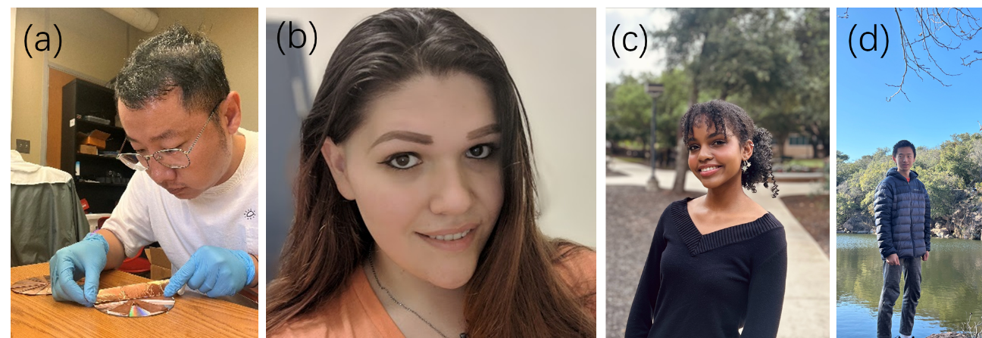

**Figure 5.** Students working on generators.

• Describe the specific roles and tasks of each student in the project.

Feng, Hong designed experiments and devices. Crystal focused on circuit design and performance measurements. Hong, Ishanel and Evan mainly fabricated the devices.

**3.2 Achievements**

**• Detail the major activities undertaken by the students and their outcomes.**

1. Designed single electrode triboelectric generators with PTFE film & copper foil and fabricated Z-shape generators with PTFE-copper and paper-copper.
2. Investigated the integration of multiple separation-contact triboelectric generators so that the output power can be multiplied.
3. Designed double electrodes “Comb” mode triboelectric generators with PTFE film, paper and copper foil.
4. Designed radial-arrayed rotary electrification for high performance triboelectric generator with PTFE film and copper or aluminum foil.
5. Improved non-contact radial-arrayed rotary electrification for high performance triboelectric generator designed last month by externally excited and self-excited systems.
6. Multilayers’ non-contact radial-arrayed triboelectric generator was designed by 3D printer this month. Basic materials are PTFE, PA, Al and Cu electrodes. Investigated the integration of this generator so that the output power can be multiplied.
7. New high dielectric constant material polyurethane (PU) foam was inserted between two horizontally placed electrodes to multiply the capacity and output power.
8. Characterized equivalent resistance, short circuit current and open circuit voltage for single-level radial-arrayed rotary triboelectric generator designed at December 2023.
9. Measured peak power delivered with respect to foam thicknesses of high dielectric tribo-positive PU Foam stator utilizing PTFE and FEP as corresponding tribo-negative rotors.
10. Designed multi-level radial-arrayed rotary triboelectric generator to be tested for series and parallel combinations.

**3.3 Future Plans for Students**

• Dr. Lin has completed his work at UH and found a faculty position at Yunnan University.

• Hong and Crystal will continue to stay at UH to complete their PhD and undergraduate studies, respectively.

• Ishanel and Evan will return to their school after the summer working period.

**4. Conclusion**

**4.1 Summary**

During this period, we primarily completed the task of illuminating blinkers and designed and completed the construction of the frictional rotating generator. The non-contact generator requires further optimization.

**4.2 Next Steps**

Further design the self-excitation system for the non-contact model, aiming to provide a consistent electrical charge to the rotor during the initial electrification phase. This will enable the induction of stable, continuous, and high-quality electrical energy on the stators during subsequent rotation processes.