**Developing Methods of Producing and Processing Marine Microalgae to Biocrude**

**PI: Dr. Venkatesh Balan**

**1. Background and Purpose**

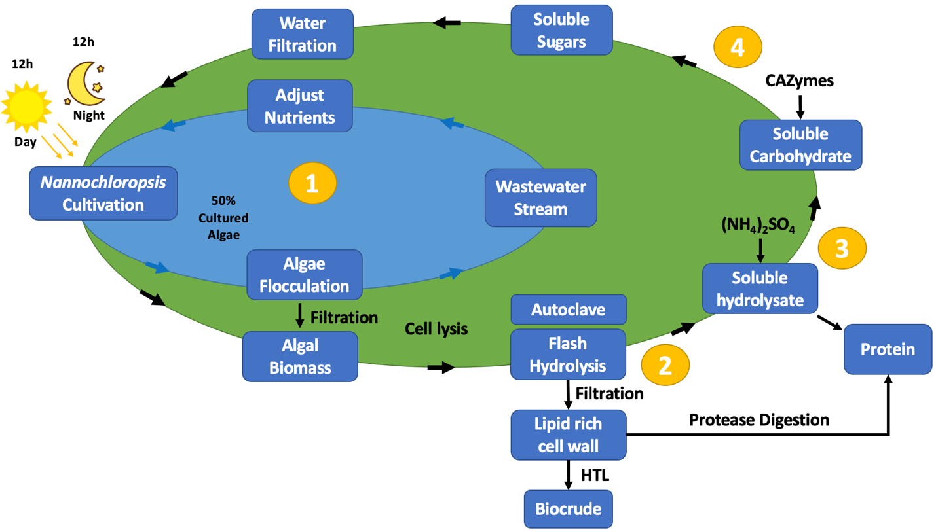

The funding received from Sub Sea Institute (SSI) was utilized for creating a closed-loop system for microalgae cultivation and processing. The project was split into two objectives; (i) algae cultivation (represented by inner blue circle) by recycling the water and hydrolyzed carbohydrates and (ii) algae processing (represented by outer green circle) to biocrude and co-products like protein as shown in the figure.

Objective 1: Algae Cultivation:

*N. gaditana*, a marine microalgae strain, was chosen for this project. This is primarily due to its ability to accumulate 35-40% lipids in seawater. We cultivated algae in a vertical photobioreactor. A significant emphasis was made on utilizing sea water to cultivate marine microalgae to alleviate costs associated with utilizing freshwater. The main goals of this sub-project included producing algae in a closed loop system, reducing water wastage, recycling nutrients, and increasing biomass productivity. Our results show that the media could be recycled approximately 3-times without change in biomass productivity. Addition of hydrolyzed sugars led to increased biomass productivity, with cultures supplied with both CO2 and sugars having the highest biomass production. Biomass productivity increased approximately four times with the addition of sugar. The students working on this project include two master students (Drashti Mojidra, Anh Ngyuen), three high school students (Meet Chokshi, Robell Ephram, and Sraavani Poluri), Ross Meade (undergraduate student) and several capstones undergraduate BTEC students.

Objective 2: Algae Processing:

After cultivation, the algae are separated through pH-induced flocculation and sedimentation. Algae biomass was lysed using two different hydrothermal treatments (Flash hydrolysis - a semi-continuous process, was operated at high temperature and pressure for shorter residence time and Autoclaving - a batch process operated at low temperature and pressure for longer residence time). Both pretreatments resulted in the formation of a lipid-rich solid stream and a protein and carbohydrate rich liquid stream. The lipid-rich solids were used as substrate for hydrothermal liquefaction to produce biocrude. The resulting bio-oil, separated from biocrude, contained high levels of carbon and hydrogen. Bio-oil also contained low levels of nitrogen and sulfur limiting issues such as slagging and fouling, which are often caused by high nitrogen and sulfur concentrations. Autoclaving was performed at various solids loading. It was observed that the extraction efficiency of proteins and carbohydrates decreased at higher solids loading indicating partial cell lysis. Main goals of this sub-project included producing high quality biocrude, protein co-product, and fermentable sugars for recycling. Students working on this project include Drashti Mojidra (master student) and Ross Meade (undergraduate student).

**2. Major Accomplishments:**

1. The results from this project will be published in two scientific journals. Tentative title of two articles is given below.
   * *Manuscript-1:* Exploring the Versatility of *Porphyridium* sp.: A Comprehensive Review of Cultivation (Submitted to Biotechnology Advances, June 2024).
   * *Manuscript-2:* Methods of Producing and Refining *Nannochloropsis* sp. to bioproducts (Under preparation).
   * *Manuscript-3:* Developing Methods of Producing and Processing Marine Microalgae to Biocrude (Under preparation).
2. Drashti Mojidra (Masters student) completed her thesis titled “Developing Methods of Producing and Processing Marine Microalgae to Biocrude”.
3. Poster presented by Drashti Mojidra titled “Developing Methods of Producing and Processing Marine Microalgae to Biocrude” won first prize in Engineering Innovation at the Algae Biomass Summit held in Madison, Wisconsin, October 11, 2023.
4. Three undergraduate students, Shumila Javed, Miguel Benitez, and William Vo, completed their senior undergraduate capstone project on producing and processing *N. gaditana*.
5. Three high school students, Meet Choksi, Robell Ephram, and Sraavani Poluri, were trained in algae cultivation methods.
6. Around 12 high school students, participating in USDA-HIS summer research training program for a month, over a 2-year period.

**3. Testimonials from Students:**

****My master’s thesis focused on developing methods of cultivating and processing the marine microalga, N. gaditana, to biocrude. The main goals of this project were to cultivate microalgae using seawater, limit nutrient wastage, produce high quality biocrude while producing protein as co-product and fermentable sugars that could be recycled for algae cultivation. An overall mass balance was calculated for the entire process. For the completion of this project, I learned various techniques including protein purification, algae cultivation, and enzyme hydrolysis. Moreover, I learned to operate several machines including high performance anion exchange chromatography (HPAEC), high performance liquid chromatography (HPLC), gas chromatography mass spectrometry (GCMS), and CHNS analyzer. I faced many difficulties in learning to properly operate these machines. However, under the expert guidance of my advisor Dr. Venkatesh Balan, I was able to complete my thesis. Due to the skills, I learned, I have been offered a job at Eurofins, Kalamazoo, MI, a global laboratory testing services company.*

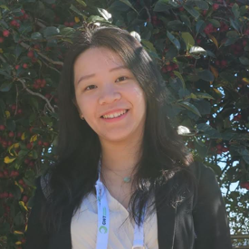

*Anh Nguyen*: *I am immensely grateful for the opportunity to share my experience working on my capstone project, which focused on developing methods for cultivating and processing the red microalgae Porphyridium sp. for high-value products such as exopolysaccharides, phycoerythrin, and polyunsaturated fatty acids. The main objective was to optimize algae cultivation and identify effective extraction methods. Through this project, I gained expertise in algae cultivation, cell lysis, and extraction and quantification techniques. Additionally, I authored a review paper on this project, which is currently under review in Biotechnology Advances. This project inspired me to pursue a master's degree, during which I completed my thesis on another algae-related project. These achievements were made possible through the invaluable guidance and support of my advisor, Dr. Balan. His encouragement has been pivotal in my academic and professional development. Presently, I am a research staff member at UH, where I lead algae projects, assist colleagues with their research, share my experience, and train students.*

*Meet Chokshi: Working on the development and cultivation of N. gaditana in a closed-loop system, along with its conversion to biocrude, has revealed numerous benefits and expanded my understanding of microalgae. This project has immersed me in a complex process involving various biochemical reactions, including enzymatic hydrolysis and protein purification. Additionally, I've gained hands-on experience with chromatography machines and separation techniques such as flocculation. Currently, my academic focus is on organic chemistry, where I am delving deeper into the field to enhance my knowledge for future research endeavors. Looking ahead, I plan to major in a scientific discipline closely related to the procedures and practices I have engaged with during this project. As a college student, I am committed to furthering my expertise through extensive literature review and practical experiences. I am profoundly grateful for the mentorship I have received, which has established a solid foundation for future lab work, emphasizing both safety practices and essential experimental procedures.*

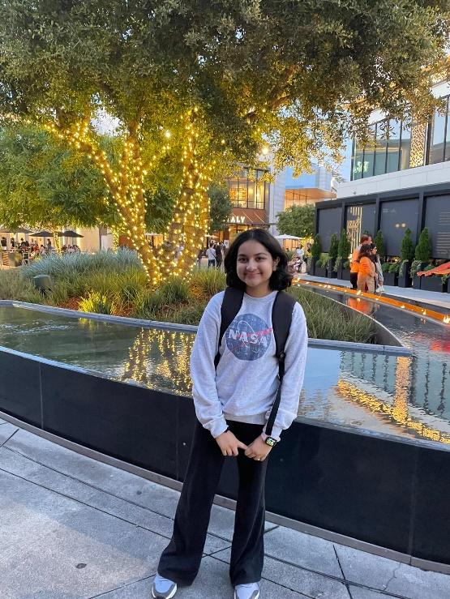

*Sraavani Poluri: As an upcoming senior at Dulles High School with a passion for biology, the recent project on enzyme hydrolysis using phytoplankton biomass has been an incredible learning experience. Through hands-on work with algae cultivation, centrifugation, and bioremediation techniques, I've gained valuable insights into the intricate world of microbiology and its potential applications. In addition, the process of preparing algae media, managing biosafety protocols, and analyzing absorbance data has sharpened my laboratory skills and deepened my understanding of experimental procedures. Not to mention, I'm incredibly grateful to Dr. Balan for providing me with this opportunity to delve into real-world research. His guidance as well as my mentor, Drashti’s have been invaluable in helping me understand the complexities of scientific inquiry and has further ignited my passion for biology and its applications in solving global challenges.*

*This project has reinforced my love for scientific research and its potential to address real-world challenges. Academically, as an officer in clubs like HOSA and Red cross, I've always been drawn to activities that combine scientific knowledge with community service. My volunteer work in hospitals has further fueled my interest in the medical field, allowing me to see the direct impact of biomedical research on patient care. Looking ahead, I'm excited about the possibilities that lie at the intersection of biology and medicine. My dream is to pursue a career either as a biomedical researcher or in the premed field, where I can contribute to advancing our understanding of diseases and developing innovative treatments.*

*Robell Ephrem: Participating in the cultivation and analysis of N. gaditana within a self-sustaining system, and its subsequent conversion into biocrude, has significantly deepened my appreciation for the potential of microalgae. I gained valuable practical experience with techniques such as chromatographic analysis and advanced separation methods, including flocculation. The project also deepened my understanding of complex biomolecular processes like lipid metabolism and protein isolation. Currently, my academic focus is on biomolecular chemistry, a field I am eager to explore further and expand upon my existing knowledge for future research endeavors. Looking forward, I aim to pursue a degree in a scientific discipline that aligns with the cutting-edge practices and techniques I've utilized throughout this project. As I prepare to enter college, I am committed to enhancing my understanding through both comprehensive academic studies and hands-on laboratory experiences. The mentorship I received has been foundational, establishing a solid base for my academic and research career, with a particular emphasis on safety and stringent experimental protocols. I am deeply grateful to Dr. Balan for the opportunity to engage in this research project, and I am confident that the skills I have developed will greatly*

**4. Proposals submitted to federal funding agencies:**

Preliminary data generated in the SSI grant was helpful in submitting two proposals to federal funding agencies.

1. **Proposal 1:** Funding Agency: Department of Energy (DE-FOA-0003002), University training and research for fossil energy and carbon management AOI 1: Visiting scholars’ program to benefit students from minority-serving institutions. Project title: Workforce training on agricultural waste carbon management and renewable energy conversion for net zero GHG future (submitted August 2023). Results: Not funded.
2. **Proposal 2:** Funding Agency: Department of Energy (DE-FOA-0002654). Topic Area 2, Algae-Based Technology to Utilize Anthropogenic from Utility and Industrial Sources CO2. Project title: Technology for Enhanced Carbon Capture for Creating Algal Bioproducts (TECC-CAB) (Submitted May 2022). Results: Not funded.
3. **Proposal 3:** Funding Agency: National Science Foundation, Project title: Global Centers Track 1: Center for Algae-based Negative Carbon Emission Technologies (CANCET) (Submitted May 2023). Results: Not funded.
4. **Proposal 4:** Funding Agency: Department of Energy (DE-FOA-0003274-MACRO-Mixed Algae Conversion Research Opportunity). Topic area 1: Conversion of Seaweeds to low-carbon fuels and bioproducts. Project title: Developing a low-cost method of producing algae biomass pellets and microbial conversion to ethanol. (Submitted July 2024). Results: Awaiting.

**5. Conference and invited presentation:**

1. Dr. Venkatesh Balan gave an invited talk ‘*Developing Methods of Producing and Processing Marine Microalgae to Biocrude*’ at Bharathi, Department of Microbiology, Bharathi Dasan University (BDU), Tiruchirappalli, Tamil Nadu, India May 20, 2024.
2. Drashti Mojidra gave an invited talk ‘*Developing Methods of Producing and Processing of Marine Microalgae to Biocrude*’ at Algal Biomass summit held in Madison, Wisconsin on October 11, 2023.
3. Dr. Venkatesh Balan made a poster presentation on the topic ‘*Continuous processing of algal biomass slurry using flash hydrolysis system and fractionating to proteins, lipids, and carbohydrate rich stream*’ at Algal BBB conference held in Hawaii, June 9, 2023.
4. Dr. Venkatesh Balan gave an invited online presentation ‘Methods of Extracting, Purification, and Characterization of high value Products from *Porphyridium* sp.’ at Food, Feed, Fuels and Fine Chemicals – ICA-F4’23 September 6, 2023.