Grant Activity Description
Grant No.
Work Order Amount $TBD
Grant Recipient: The University of Houston - Subsea Systems Institute
Period of Performance: Upon execution of NTC – 10/30/2025

Magnetic Mapping on Monitoring of Underwater Assets

using Underwater Robots

Preliminary Report

Background and Purpose

Inspection and maintenance of underwater assets is an important task that requires intensive sensing. Environmental challenges make it difficult for human operators to perform this sensing. Remotely Operated Vehicles (ROVs) can carry the sensors to perform the task, but that comes with its own challenges, such as localization and collision avoidance. Murky waters and moving sediment increase the challenge, as they can render visual and acoustic feedback useless. Figure 1 shows an example of an ROV (Remotely Operated Vehicle) maneuvering underwater through a ferrous structure with the help of magnetic sensing.
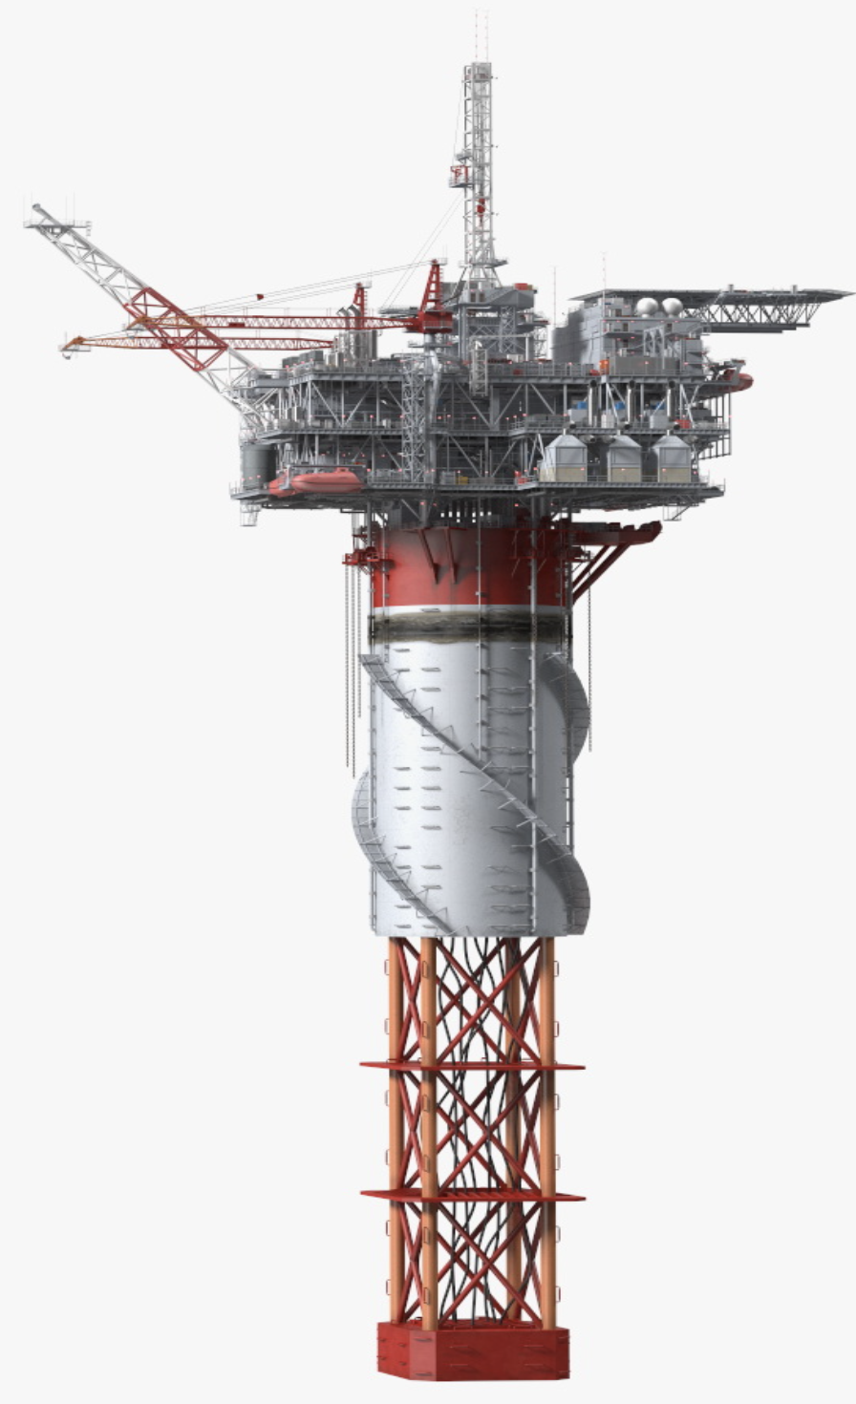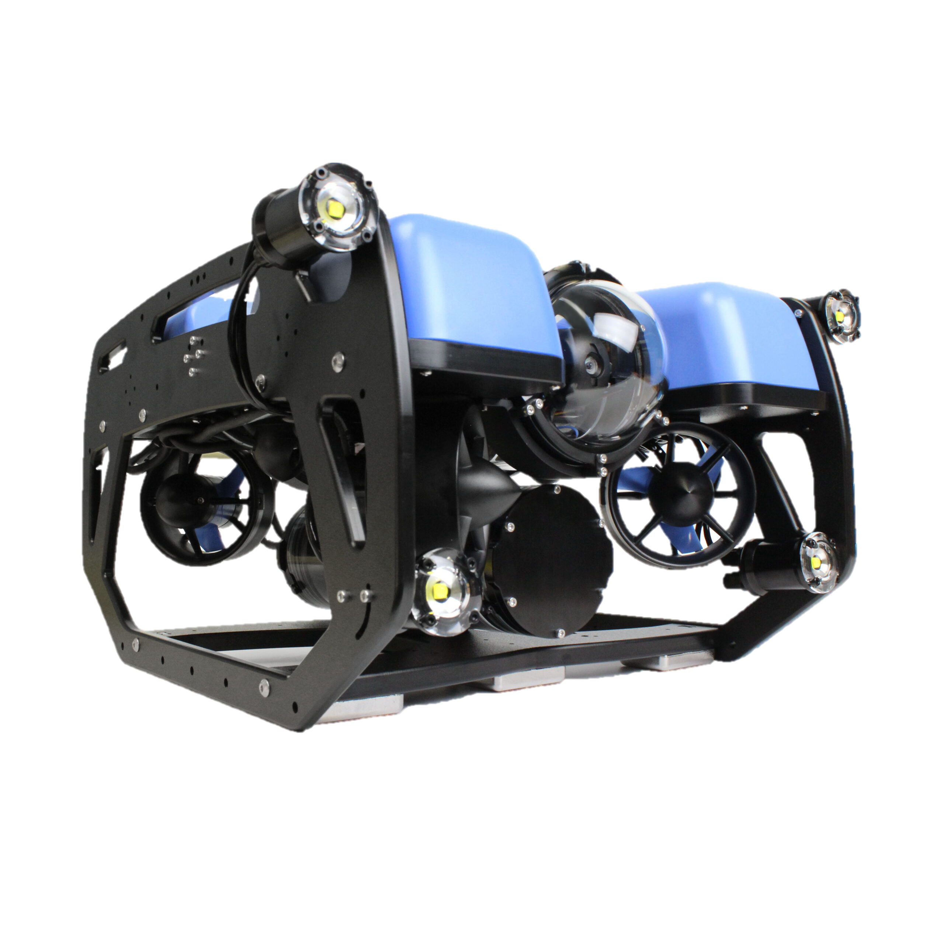
Figure 1. ROVs navigating through ferrous structures underwater.
Many underwater assets including pipelines, mooring lines, trusses, and armored cables are ferrous. That means they can be detected by magnetic sensors. Unlike acoustics, a magnetic sensor can see ferrous objects buried underground and, unlike a camera, are not affected by visibility conditions. Our lab designed and tested a “magnetic camera” consisting of an array of Hall-effect sensors and an electromagnet. The electromagnet is pulsed to generate a strong magnetic field. Any ferrous objects in the vicinity are temporarily magnetized. The array of sensors detects anomalies in the generated field, revealing an image showing the ferrous object. This camera was mounted on a Remotely Operated Vehicle ROV and tested in a pool with a mockup pipeline consisting of ferrous pipes. Using only magnetic sensing, the ROV detected and followed these pipes (Fig. 2). We also built a similar sensor that uses an array of commercially available fluxgate magnetometers to passively detect objects that distort the Earth’s magnetic field. This sensor has the advantage of not needing an external magnetic field generator (like the electromagnet we use for our magnetic camera) but has a shorter sensitivity range.

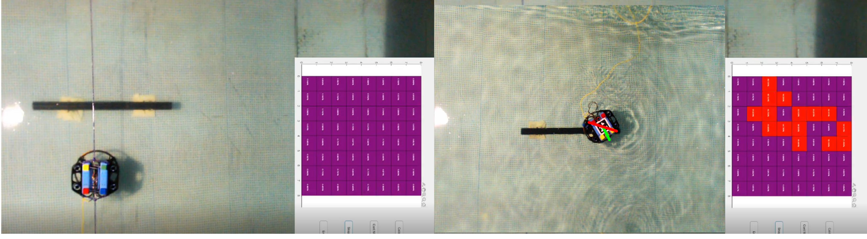
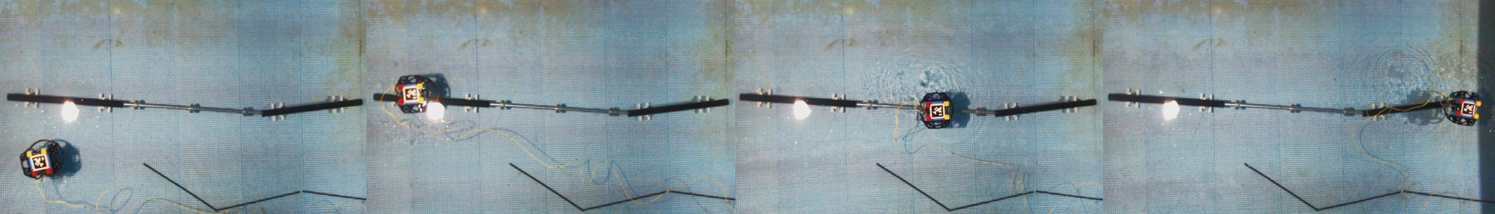
Figure 2. (Top) Sample outputs from our magnetic sensor when used to construct a binary image. (Bottom) Example of our ROV detecting and following a ferrous pipe underwater using only our magnetic camera prototype. The sequence is left to right. Note that the pipe has distinct segments.

2. Completed Work and Results

The magnetic camera operates on the principle of magnetizing ferromagnetic materials and reading the resulting distortions. Although there are equations that describe the distortion of a magnetic field due to ferrous objects, computing analytical solutions is a time-consuming process. Factors such as the shape, composition and orientation of the object affect the resulting field distortions. To speed up the design of the camera, we relied on simulation software to visualize the response patterns to ferrous objects we expected to sense in our initial underwater tests. An example of the simulation setup is shown in Fig. 3 and representative result curves are shown in Fig. 4.
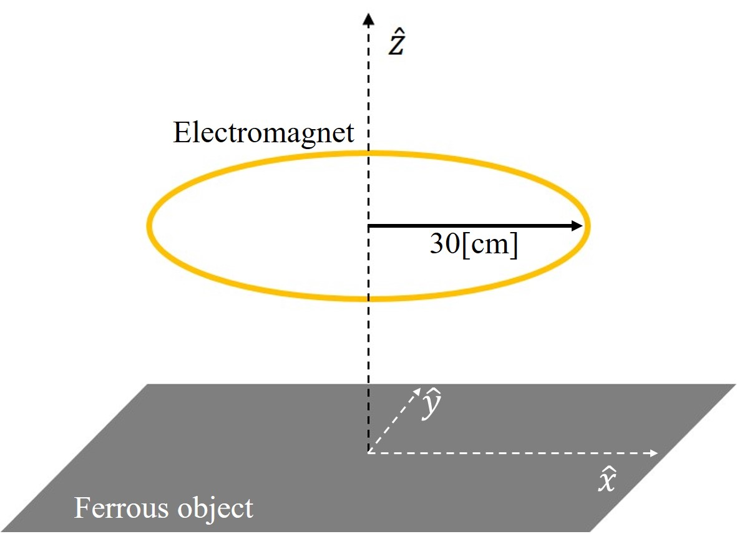
Sensor
array
Figure 3. Setup used in magnetic camera simulations. The electromagnet characteristics were chosen to closely match the real component.
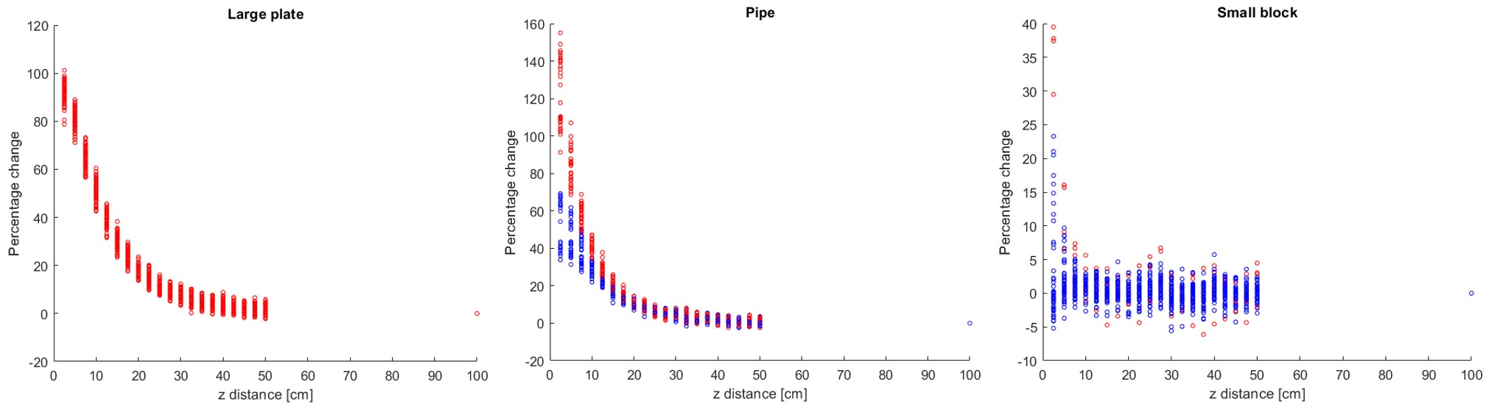
Figure 4. Example results from simulations. The red dots represent sensors overlapping three different objects. The percentage difference with respect to a reference frame (no magnetic distortion) helps us estimate the presence of a ferrous object.
Based on the simulation results, magnetic camera prototypes were constructed and tested. We chose to use an electromagnet instead of permanent magnets because we wanted to be able to control when the field is created. There are several tradeoffs. The more current that is used in the electromagnet, the greater the distance objects can be sensed from, but this greater range requires more power. Our current prototype draws over 200 A at 24 V. Another tradeoff is the sensing rate (the number of frames captured per second). Sensing more often gives better time resolution but uses more energy. We chose to capture a new frame every half a second.
We chose Hall-effect sensors because of their ease of use and their wide-spread availability. The Hall-effect probes measure the component of the field that is perpendicular to the face of the sensor. This orientation enables for a panel design on a printed circuit board (PCB). We also tested and measured the signal to noise ratio of Tunnel Magneto-Resistance (TMR) sensors in laboratory settings. These sensors proved to have a signal to noise ratio approximately five times larger than Hall effect probes. We however choose not to use TMR sensors because they sense the magnetic field component that is parallel to the face of the sensor, making the design and fabrication of an array challenging.

Custom PCBs (Printed Circuit Boards) were designed to hold a 4x4 array of Hall-effect sensors (Fig. 5). The PCBs were also designed to be daisy-chained (linked end-to-end), to easily increase the number of sensors. Once we were satisfied with the performance of the prototype, we waterproofed the sensors and mounted them on a tray to be carried by one of our ROVs, as shown in Fig. 6. Waterproofing was achieved by encapsulating the electronics inside silicone.
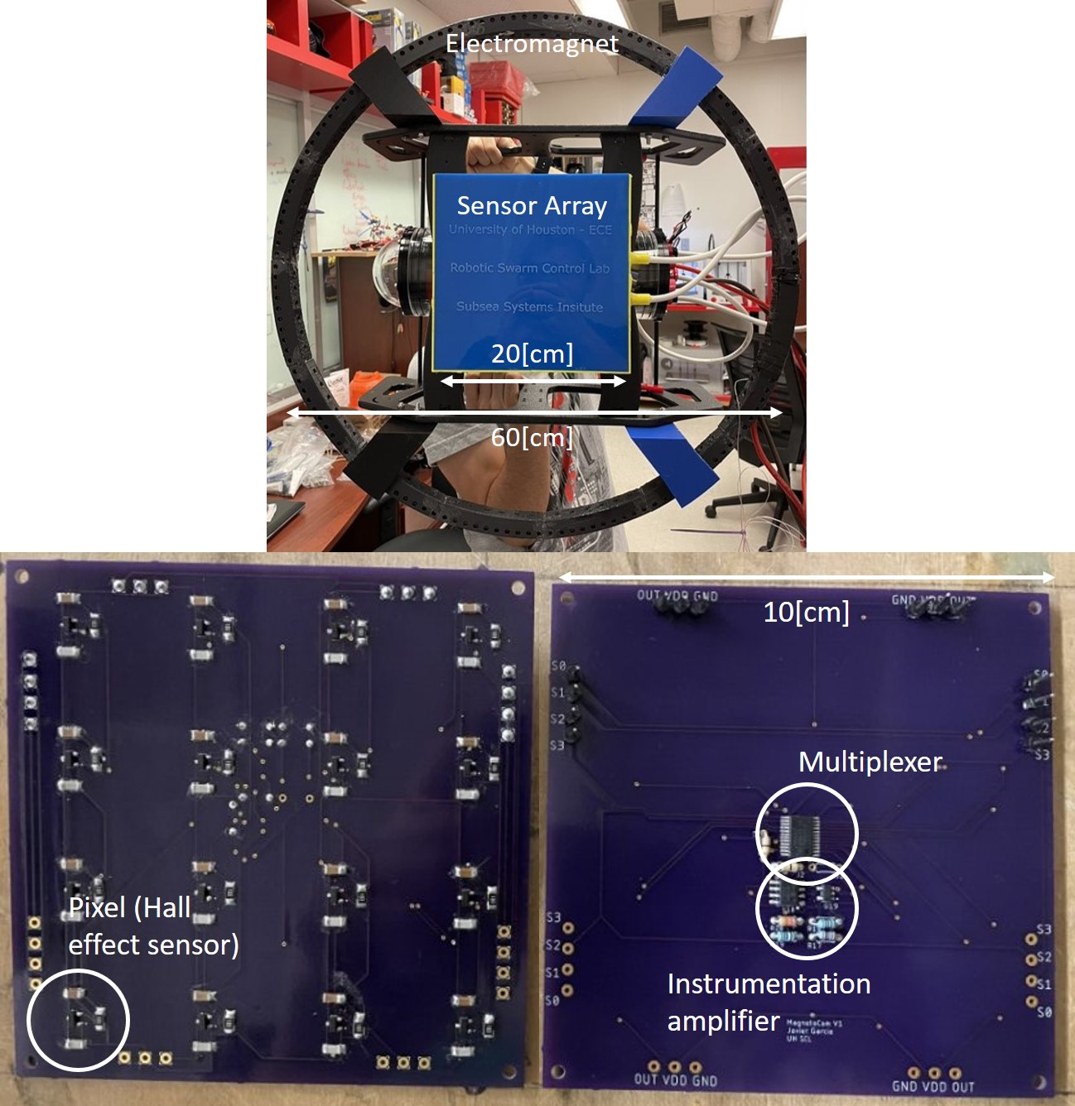
Figure 5. Custom PCBs designed for magnetic camera prototype. 16 sensors are interfaced using a multiplexer for scalability. An amplifier lets us focus on a narrower dynamic range.
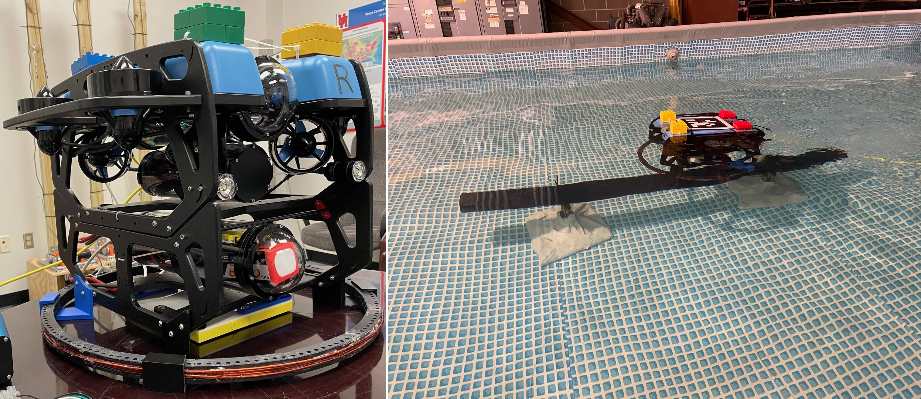
Figure 6. (Left) Electromagnet and waterproofed sensor array mounter on tray, electronics in an enclosure behind. (Right) ROV carrying the magnetic camera prototype on the bottom.
The prototype was first used to map ferrous pipes placed in a pool. The ROV was driven manually, with the magnetic camera taking data every 2 s. For most of our tests, the distance between the sensor array and the pipes was nominally 20 cm (about 8 in). A camera suspended from the roof of the testing facility was used to extract the pose of the ROV during postprocessing. Figure 7 shows representative mapping results. Since the magnetic camera and the overhead camera are synchronized (the topside computer requests data from both at the same time), the sensor values are represented as a color map with the same pose as the ROV. Not only was the camera able to see the pipes clearly, but some features such as flanges and changes in pipe diameter were detected.

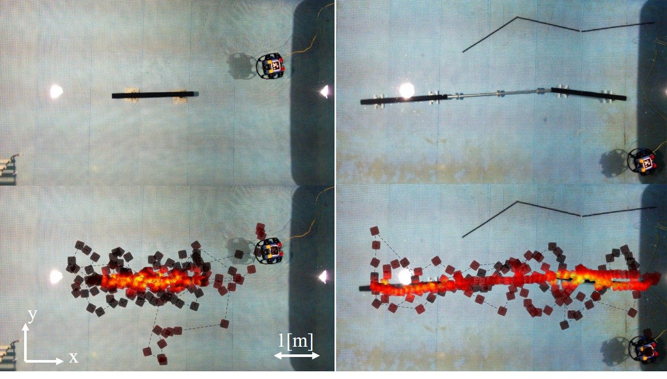
Figure 7. Maps of underwater ferrous pipes. Brighter spots indicate higher activity.
Our next tests focused on automatic pipe detection and tracking using magnetic data only. Since the sensor array is a square grid, the relative position of the pipe’s center of mass and its orientation can be quickly computed using the sensor values. Once a pipe is detected and its orientation calculated, the ROV can begin tracking the pipe. To test this, we implemented a robust controller. First, the ROV moves forward until it detects a pipe. Then, the ROV rotates left or right until the ROV forward axis is aligned with the sensed pipe orientation. The ROV then follows the pipe while correcting for orientation and lateral errors. Different pipe configurations were used. The overhead camera provided footage with which the controller performance was analyzed, in terms of position and orientation errors. Figure 8 shows three results. Although there is considerable oscillation around the zero-error lines, the ROV was able to detect and track the pipes satisfactorily.
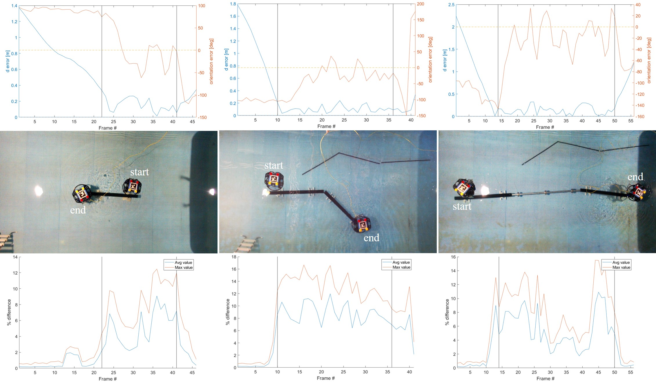
Figure 8. Three examples of the ROV autonomously detecting and tracking different pipes. The plots on the top show the orientation (orange) and position (blue) errors. The black iron pipes are 6[ft] long.
The previous results, in more detail, were submitted in a paper to the Institute of Electrical and Electronics Engineers International Conference on Automation Science and Engineering (IEEE CASE 2024) conference. This paper was accepted for publication and presentation. We also submitted a patent application, “Magnetic Camera and Imaging Ferrous Objects” (U.S. Provisional Patent Application No.: 63/661,687). Our working prototype is visually appealing and reliable, so we have provided live demonstrations to visiting dignitaries, including representatives of the US Treasury Department.

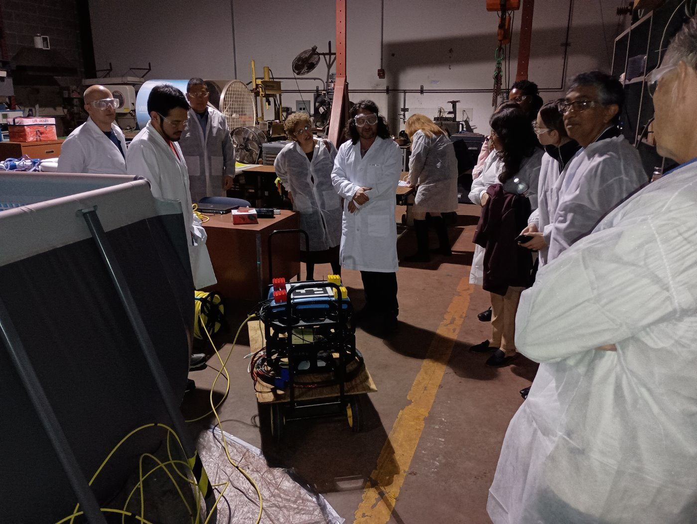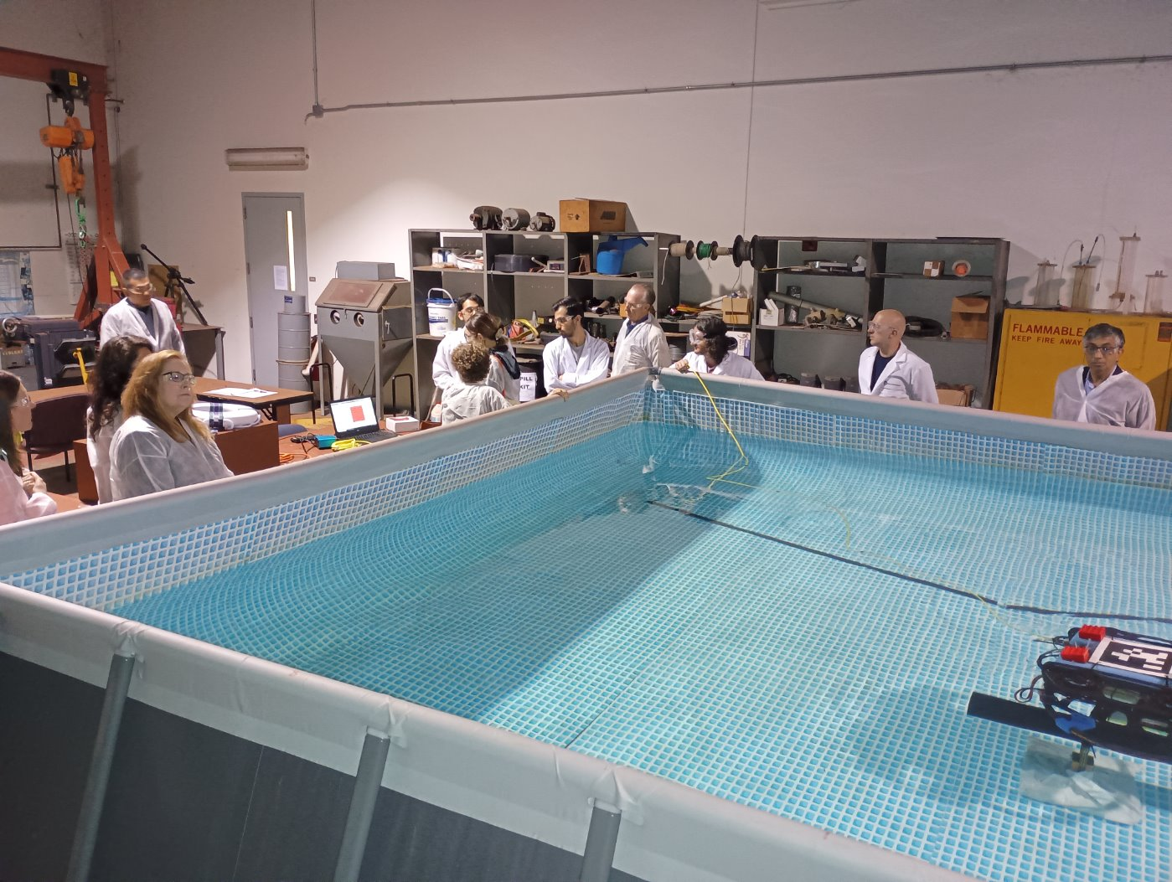
Figure 9. Showing our ROV with the magnetic camera prototype to representatives of the US Treasury. Pipe tracking demos were successfully performed.

3. Students and Postdocs

The grant has supported several high-performing students at the University of Houston these include: Javier Garcia, whose work on the magnetic camera was a key part of his PhD dissertation; Francesco Bernardini and Mohammadreza Shahsavar, who are earning their PhDs; Master of Science student Ryan Lewis, and a team of undergraduates Conlan Taylor, David Galicia, Jeser Hernandez, Arlene Orozco who designed a cable-robot rig for testing our magnetic sensors “Underwater Robotic Platform” Fall 2022–Spring 2023. This team was honored Spring 2023, as one of the two capstone design teams selected as the best of engineering and presented their project to the Engineering Leadership Board audience.

Javier Garcia, Ph.D.
Dr. Garcia led the magnetic camera project from its beginning. His contributions include setting up simulations of the magnetic camera and analyzing the results to design the different components. He designed and tested several prototypes including the current version. Integration of the camera with the ROV, as well as the implementation of the communication with the topside computer and control schemes were also his doing. Many of the results shown above are included in his Ph.D. dissertation, which he successfully defended December 2023. He is now a postdoc researcher at the Swarm Control Lab.

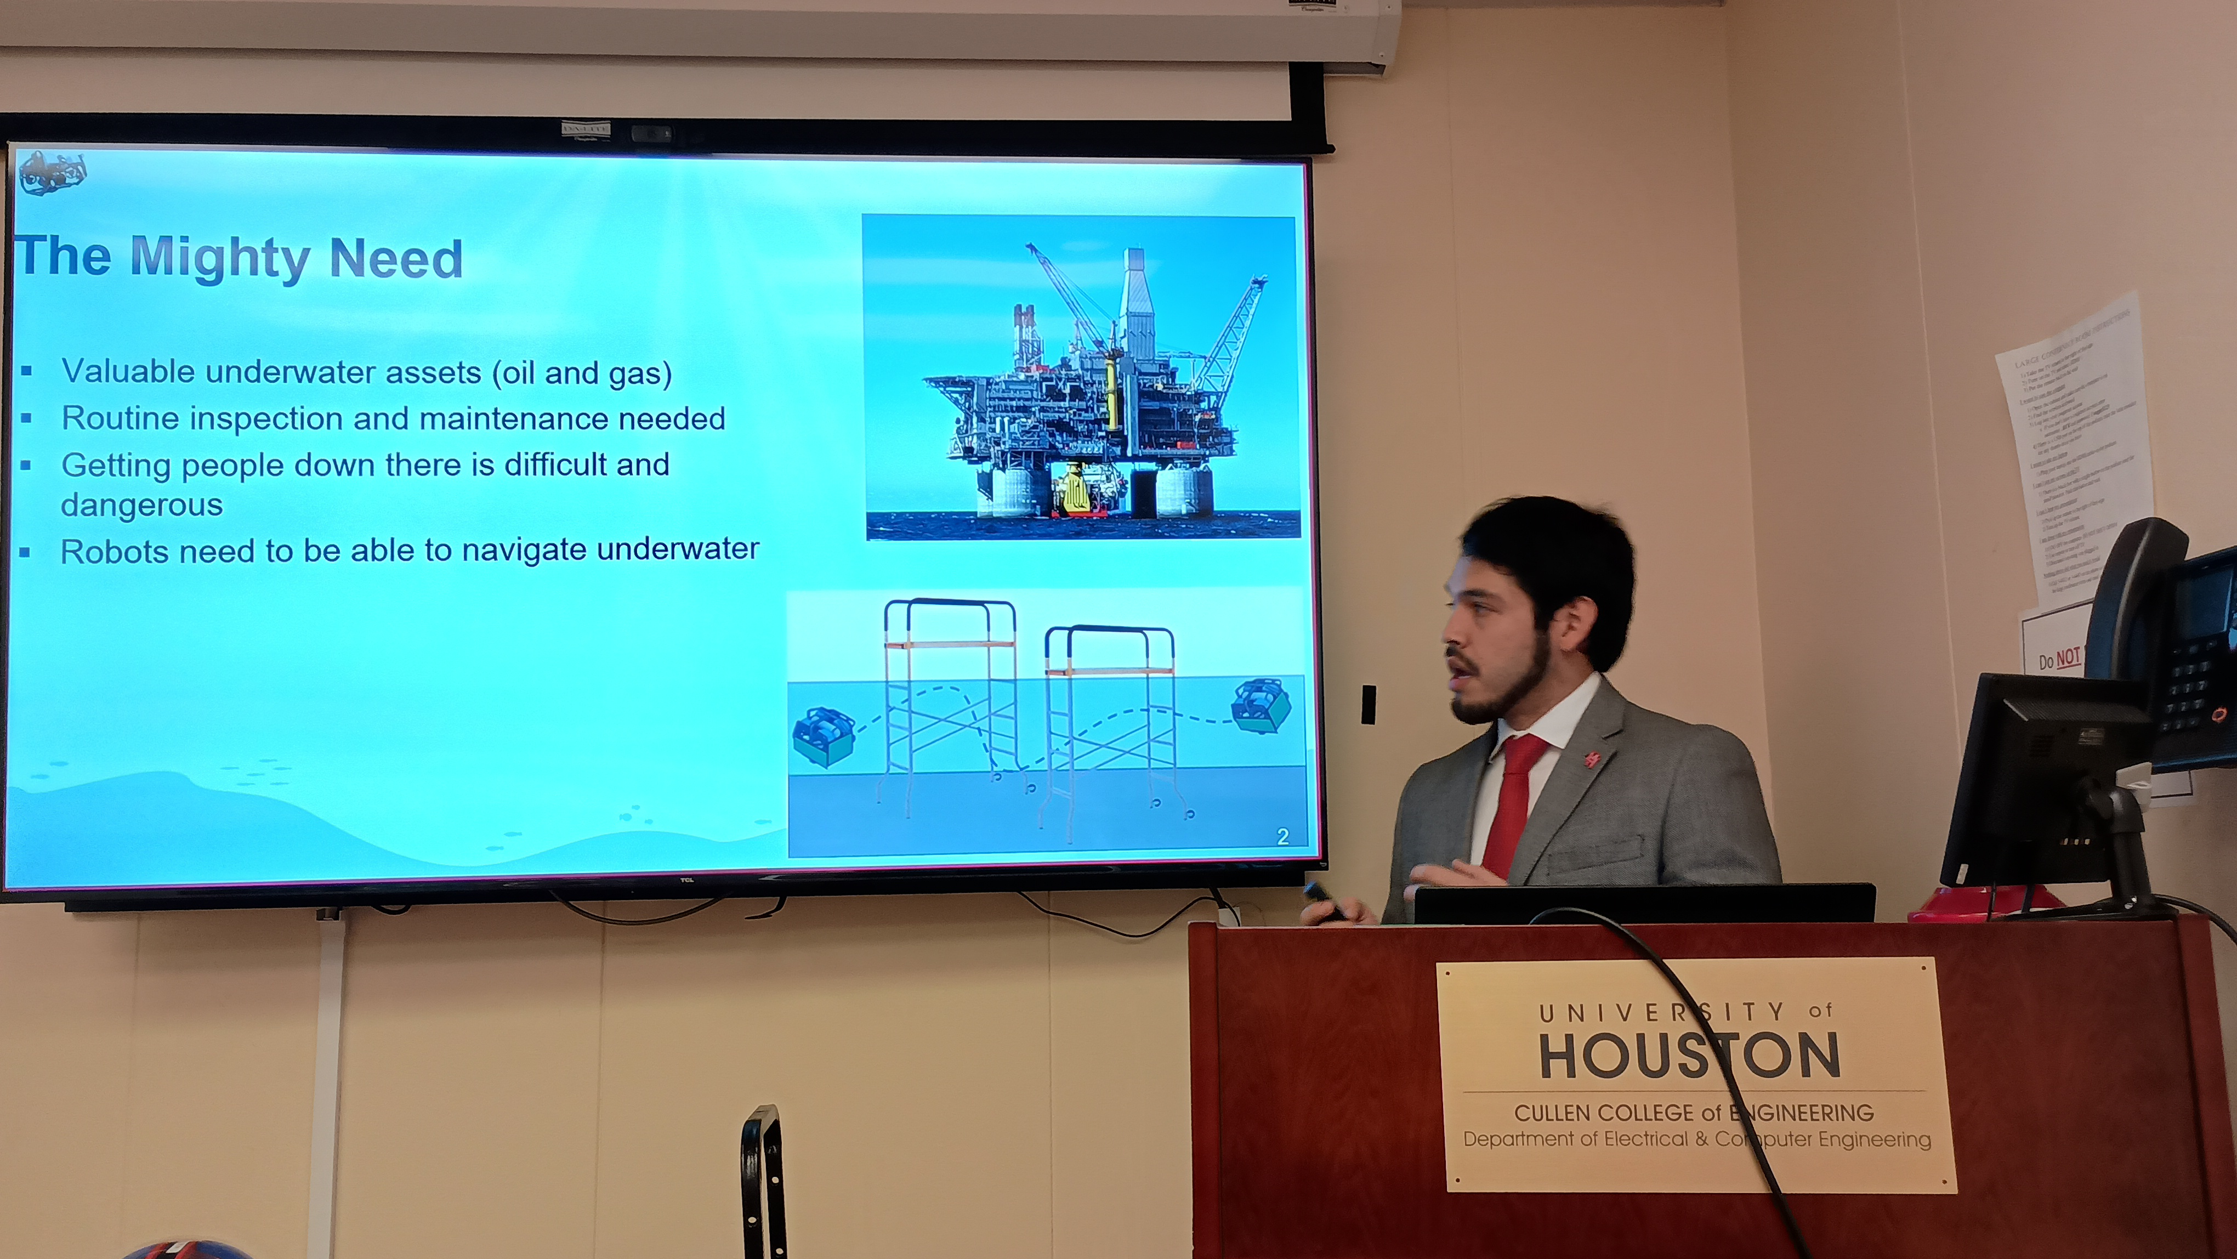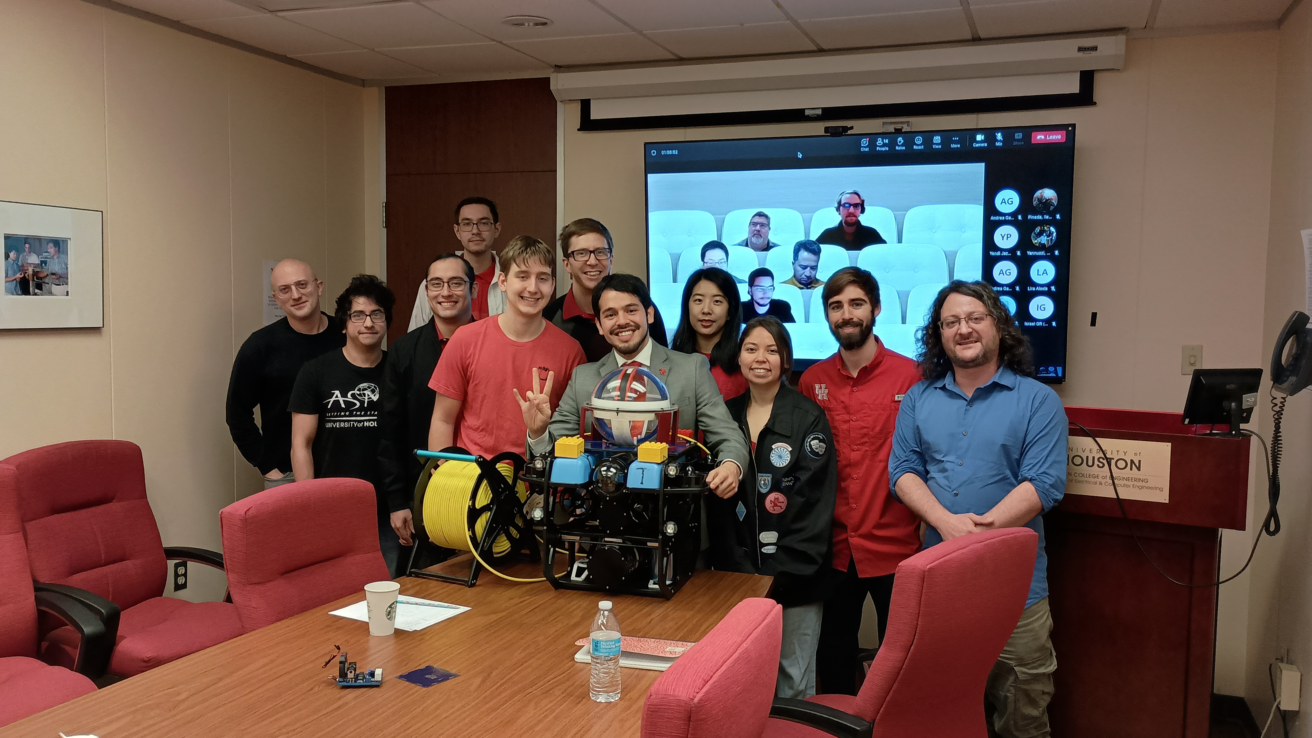
Figure 10. Dissertation defense of Dr. Javier Garcia, supported by PGA/GAD

Mohammadreza Shahsavar, Ph.D. student
Mr. Shahsavar’s contributions include the design of PID controllers for the ROV. He designed algorithms for steering the ROV around obstacles while using magnetic sensing. He performed multiple MATLAB simulations, which implement a physical model of the ROV moving underwater. His controllers will be implemented in the future to improve the performance of the pipe tracking, by counteracting the low sensing rate with a predictive step.

Francesco Bernardini, Ph.D. student
Mr. Bernardini joined the SSI project in Fall 2022, focusing on applications of magnetic induction underwater. He studied applications of fluxgate magnetometer sensors to ferrous material detection and automatic ROV control, supporting tests of the magnetic camera. His expertise covers hardware and embedded design, 3D modeling and simulations (MATLAB, Ansys).

Ryan Lewis, Master of Science student
Ryan has investigated magnetometer applications. Low-cost magnetometer sensors are used in many types of modern electronics, including the compasses used in cell phones. Ryan developed a method to use sets of these magnetometers to detect magnets and ferrous objects without using an electromagnetic coil. We recently tested one of his prototypes in the pool. There was unambiguous evidence of detection, although the results are still under evaluation. We plan to conduct further testing as additional funding becomes available.

Senior Design team: ``Underwater Robotic Platform'', Conlan Taylor, David Galicia, Jeser Hernandez, Arlene Orozco. Fall 2022--Spring 2023

This grant supported a senior design team composed of two electrical engineering students and two mechanical engineering students. All of these students are now either full-time engineers or in graduate studies. The students designed, built, and tested a cable robot capable of positioning our robot chassis in the pool.

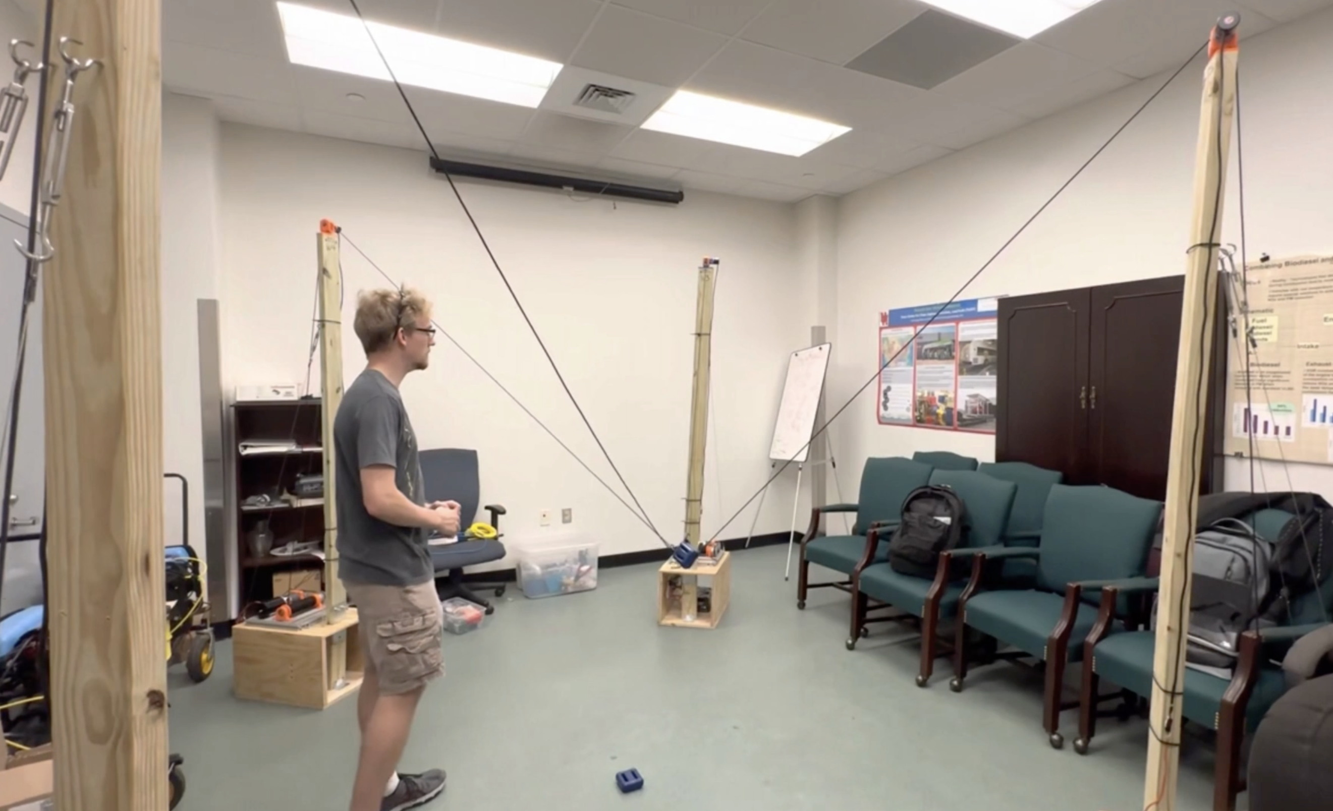
Figure 11. Conlan Taylor, supported by PGA/GAD, testing his team’s cable robot in an office facility.

4. Future Work

We propose to improve our current magnetic camera system by testing new types of sensors and exploring relevant field generation techniques. The main purpose is to increase the resolution and range (sensitivity) of the system. This would be beneficial for inspection and mapping tasks. In addition, we want to decrease the power-cost and increase the data-rate of the camera, for longer running time and faster magnetic feedback.

- The study will focus on the design and testing of different magnetic cameras. In the 12-month study, we propose to: Build a magnetic camera using TMR sensors and an electromagnet and test them underwater. We use the experimental evaluation regime we tested on the Hall-effect camera, including pipe detection, mapping, and following. The performance will be compared in terms of detected pipe position, orientation error, and range.
- Use multiple Fluxgate magnetometers to measure changes to the local magnetic field caused by magnetic objects. Fluxgate magnetometers are commonly used for finding buried pipelines, for archaeological surveys, and for seafloor surveys. We will build upon the one-dimensional sensor prototype designed in our lab, modified for 3D exploration and navigation.
- Study the use of a permanent magnet array instead of an electromagnet. The sensor arrays will be the same as in 1. Permanent magnets do not require power and would allow for higher sensing throughput. However, since they are always generating a magnetic field, they could affect other sensors in the ROV and get dangerously attracted to surrounding ferrous structures.
- Study and develop a method to “turn off” an array of permanent magnets, to mitigate the drawbacks mentioned in 3. Approaches such as changing the orientation of the magnets with motors and using a secondary electromagnet are being considered.
- Mount multiple magnetic cameras on the ROV to perform 3D mapping and collision avoidance. Testing will be performed with vertical pipes in addition to horizontal pipes underwater.

Improving Magnetic Sensing of Underwater Assets

Project Extension Proposal

1. Background and Purpose:
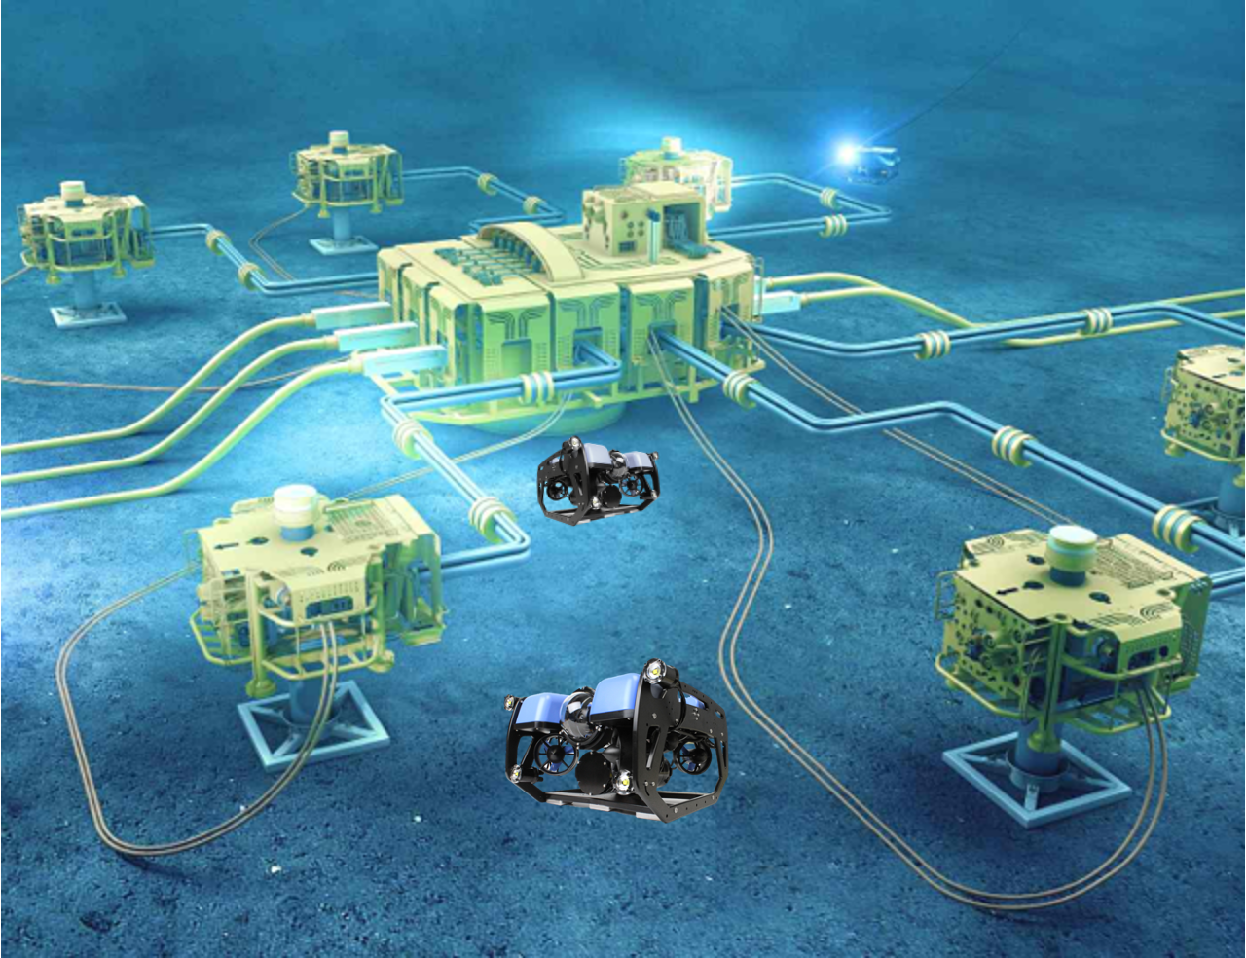
Inspection and maintenance of underwater assets is an essential task that requires accurate, repeated sensing. However, environmental challenges make it difficult for human operators to perform this sensing. Remotely Operated Vehicles (ROVs) can carry the sensors to perform the task, but this comes with a host of challenges, such as localization and collision avoidance. Murky waters and moving sediment exacerbate the situation.

Thankfully, many assets such as pipes are ferrous and can be detected with the help of magnetics. Unlike acoustics, a magnetic sensor can see ferrous objects buried underground, and are not affected by visibility conditions unlike a camera. We designed and tested a “magnetic camera” consisting of a square-array of Hall-effect sensors and an electromagnet. As the electromagnet sends pulses, the sensors detect anomalies in the generated field. The camera was mounted on an ROV and tested in a pool with ferrous pipes. Using magnetic data only, the ROV was able to detect and follow these pipes.

To continue this study, we will improve the performance of the camera, particularly in terms of resolution and detection range. In addition to increasing the density of sensors, we want to study other sensors such as tunnel-magneto resistance (TMR) sensors. The literature and our own preliminary results show that TMR sensors have higher sensitivity. We also will study using permanent magnets instead of an electromagnet to generate a magnetic field. Permanent magnets have been used in previous works and have the advantage of not needing power which reduces the weight the ROV must carry (batteries and related components) and increases run-time. However, permanent magnets are always attracted to ferrous materials, making it hazardous to maneuver near pipes or other structures. Therefore, we are also interested in methods to temporarily “turn off” permanent magnet arrays.

2. Grantee’s Key Personnel:
Principal Investigator:
Aaron Becker, Ph.D.
Associate Professor of Electrical and Computer Engineering
University of Houston
Dept. of Electrical and Computer Engineering
N308 Engineering Building 1
4726 Calhoun Road
Houston, TX 77204-4005
713-743-6671
atbecker@uh.edu

Co-Investigator:

Javier Garcia, Ph.D.
Postdoctoral Researcher, University of Houston
Dept. of Electrical and Computer Engineering
N356 Engineering Building 1
4726 Calhoun Road
Houston, TX 77204-4005
jgarciag@central.uh.edu

3. Technical Approach/Method:

3.1 Scope of Work

Research Tasks:
In this project we propose to improve our current magnetic camera system by testing different sensor types and field generation techniques. The main purpose is to increase the resolution and range (sensitivity) of the system. This would be beneficial for inspection and mapping tasks. In addition, we want to decrease the power-cost and increase the data-rate of the camera, for longer running time and faster magnetic feedback.

- The study will focus on the design, testing, and optimization of different magnetic cameras. In the 12-month study, we propose to: Build a magnetic camera using TMR sensors and an electromagnet and test it underwater. We will perform the same kind of tests as we did for our Hall-effect camera, including pipe detection, mapping, and following. The performance will be compared in terms of detected pipe position, orientation error, and range.
- Use multiple Fluxgate magnetometers to measure changes to the local magnetic field caused by magnetic objects. Fluxgate magnetometers are commonly used for finding buried pipelines, for archaeological surveys, and for seafloor surveys. We will use similar methods modified for 3D exploration and navigation.
- Study the use of a permanent magnet array instead of an electromagnet. The sensor arrays will be the same as in 1. Permanent magnets do not require power and would allow for higher sensing throughput. However, since they are always generating a magnetic field, they could affect other sensors in the ROV and get dangerously attracted to surrounding ferrous structures.
- Study and develop a method to “turn off” an array of permanent magnets, to mitigate the drawbacks mentioned in 3. Approaches such as changing the orientation of the magnets with motors (so-called ‘magnetic lock’) and using a secondary electromagnet are being considered.
- Mount multiple magnetic cameras on the ROV to perform 3D mapping and collision avoidance. Testing will be performed with vertical pipes in addition to horizontal pipes underwater.

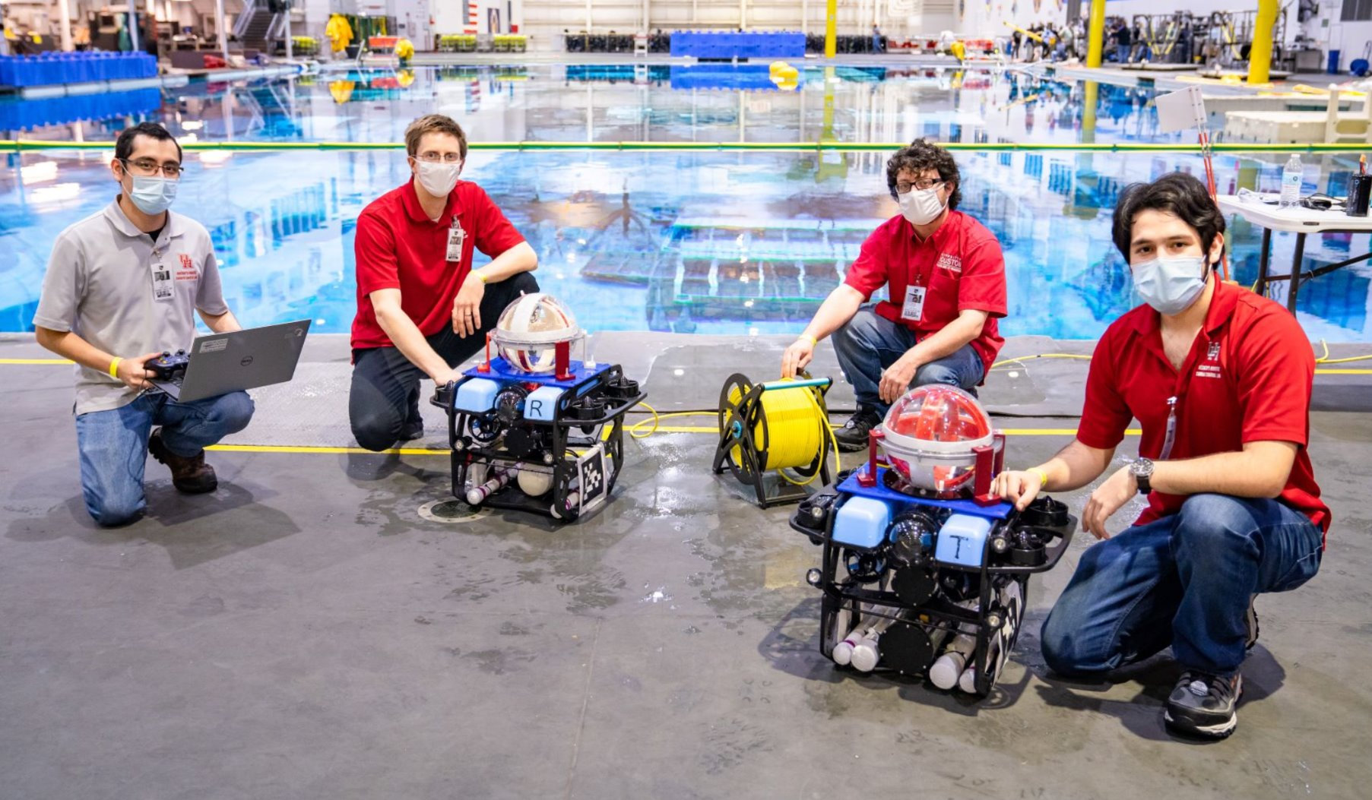
The robotic swarm lab pictured while testing two of their underwater robots at NASA’s NBL (Neutral Buoyancy Laboratory).

